|  |
| --- |
| **Developing a Backend Administrative portal**  **for**  **Learner’s Academy**  **(Application Screenshots)** |

**Version History**

|  |  |
| --- | --- |
| Author | K.Swathi |
| Purpose | Screenshots of the Application |
| Date | 30/09/2021 |

**Main Folder 🡪 To create a new Dynamic Web Project 🡪 package🡪 classes folder ,servlets folder and in WEBINF-Jsp files**

**1.com.swaraj.dao**

* **ClassesDao.java**
* **StudentDao.java**
* **SubjectDao.java**
* **TeacherDao.java**
* **UserDao.java**

**2.com.swaraj.model**

* **Classes.java**
* **Student.java**
* **Subject.java**
* **Teacher.java**
* **User.java**

**3.com.swaraj.servlets**

* **ClassesServlet.java**
* **StudentServlet.java**
* **SubjectServlet.java**
* **TeacherServlet.java**
* **UserServlet.java**

**WEBINF:- JSP Files**

* **Assign-subject-class.jsp**
* **Class-report.jsp**
* **Error.jsp**
* **Login.jsp**
* **Menu.jsp**
* **Student-classes.jsp**
* **Teacher-class-subject.jsp**

**Main.Webapp.classes**

* **class-form.jsp**
* **class-list.jsp**

**Main.Webapp.student**

* **student-form.jsp**
* **student-list.jsp**

**Main.Webapp.subject**

* **subject-form.jsp**
* **subject-list.jsp**

**Main.Webapp.teacher**

* **teacher-form.jsp**
* **teacher -list.jsp**

**Main.Webapp.user**

* **user-form.jsp**
* **user-list.jsp**

**METAINF 🡪Maven🡪SchoolManagement🡪com.swaraj🡪pom.xml**

**Project Explorer - screenshot**

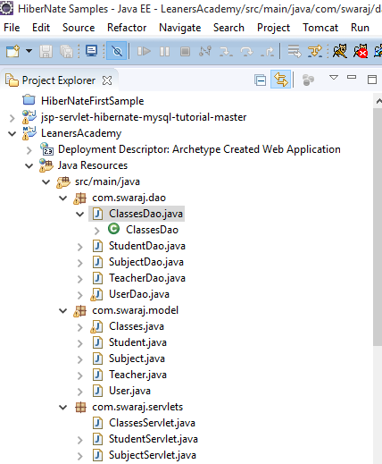

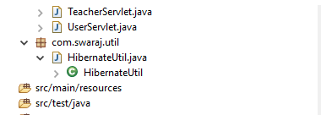

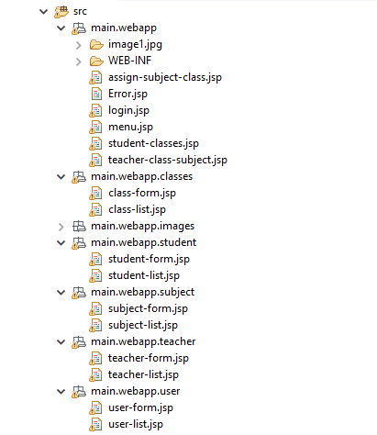

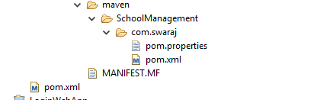



**Source Code:-com.swaraj.dao 🡪1) ClassesDao.java**

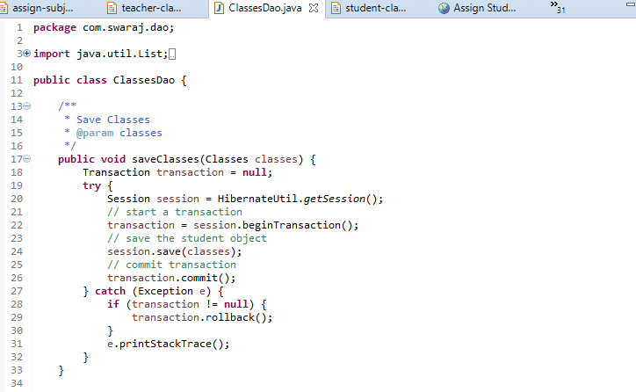

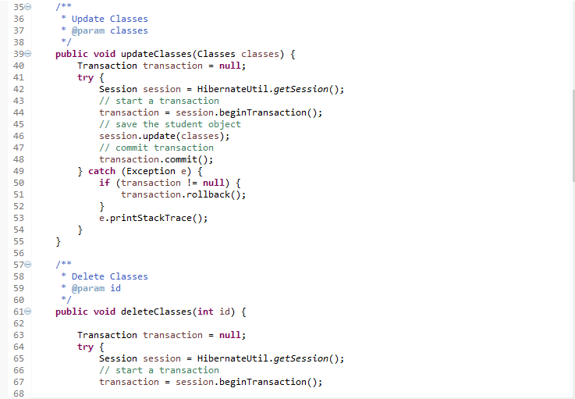

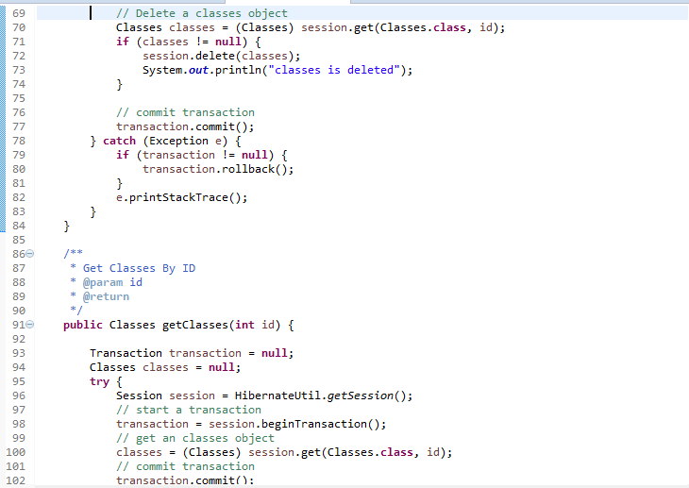

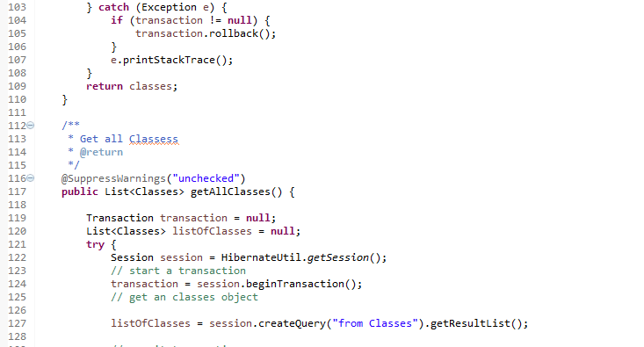

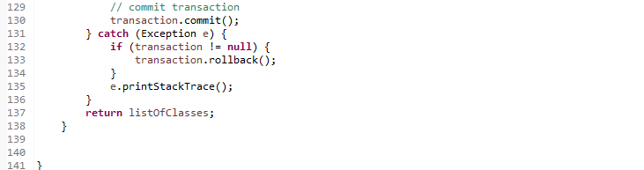

**Source Code:-com.swaraj.dao 🡪2) StudentDao.java**

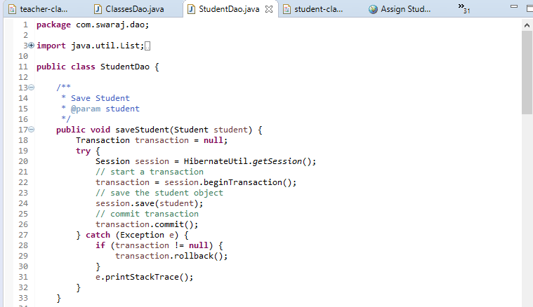

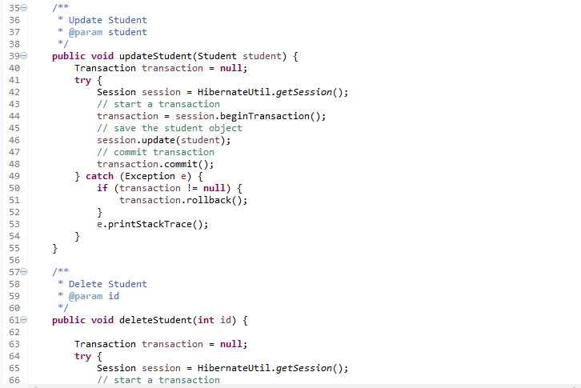

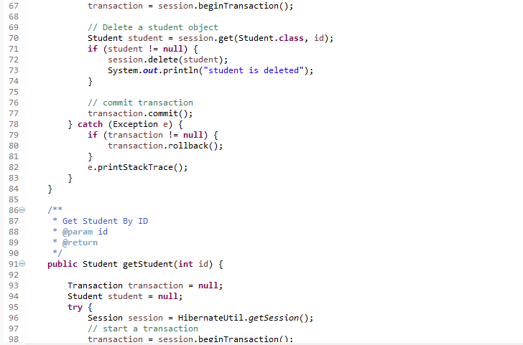

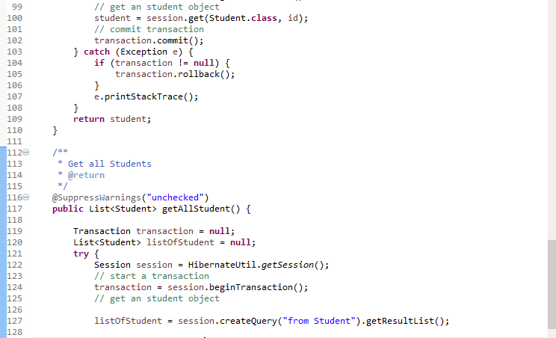

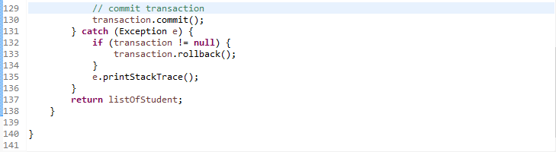

**Source Code:-com.swaraj.dao 🡪3) SubjectDao.java**

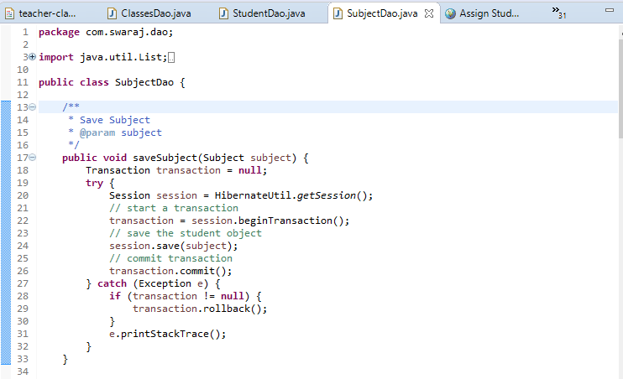

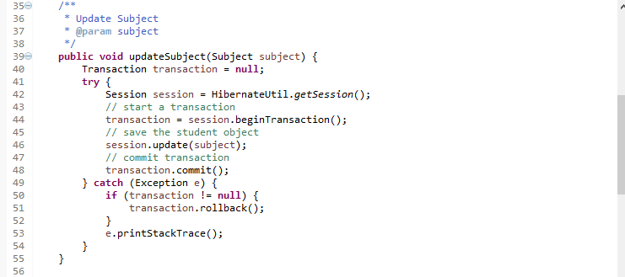

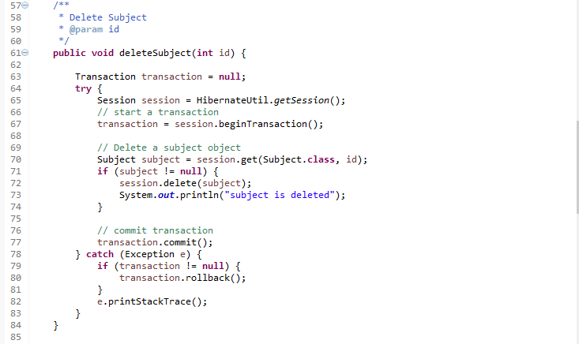

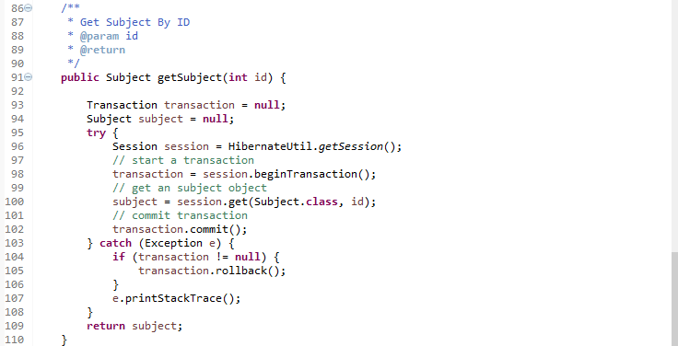

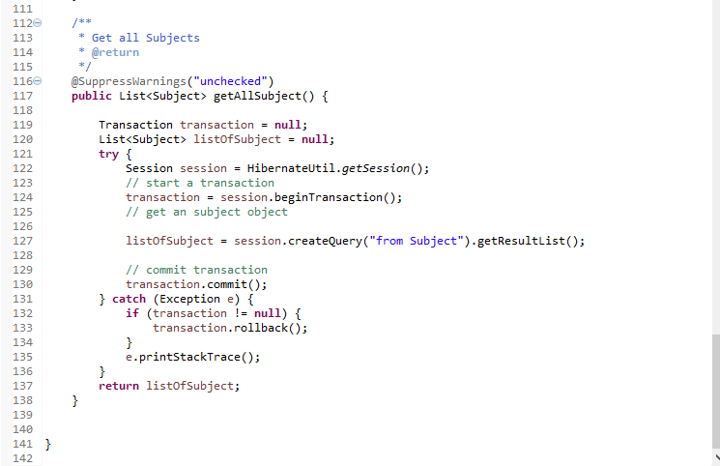

**Source Code:-com.swaraj.dao 🡪4) TeacherDao.java**

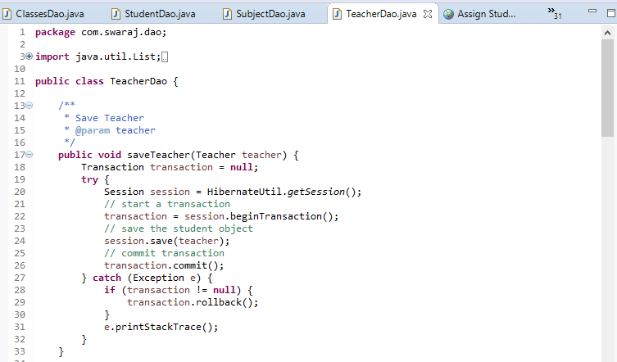

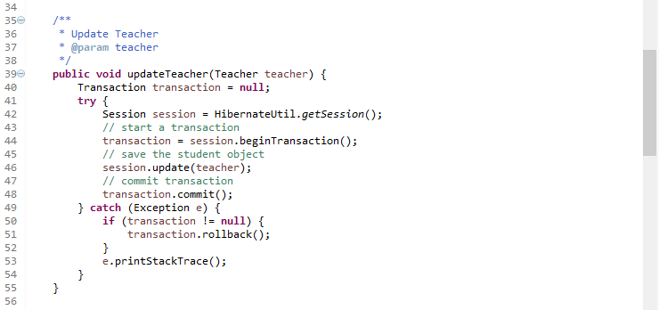

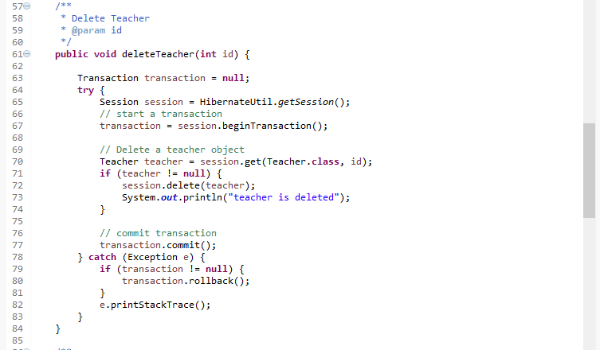

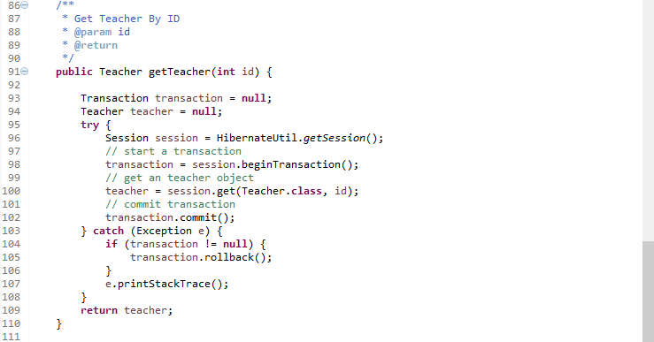

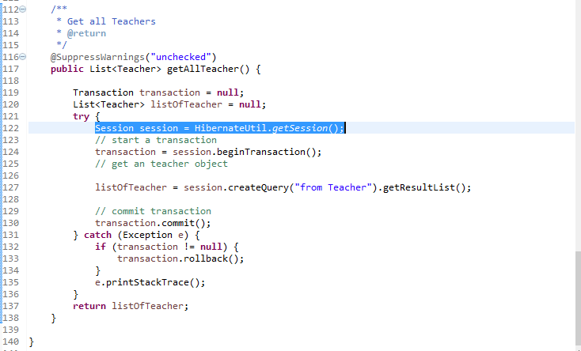

**Source Code:-com.swaraj.dao 🡪5) UserDao.java**

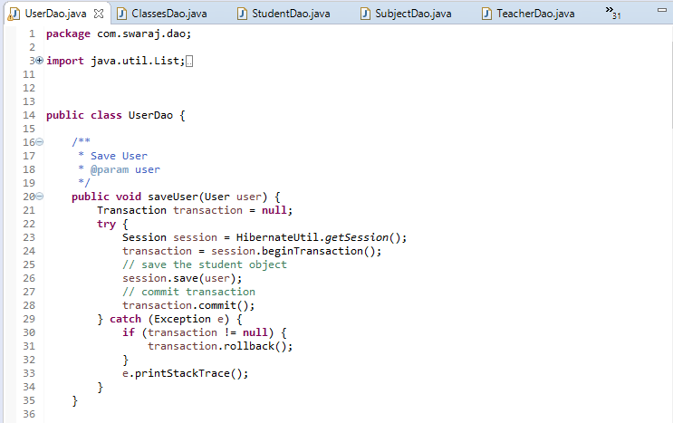

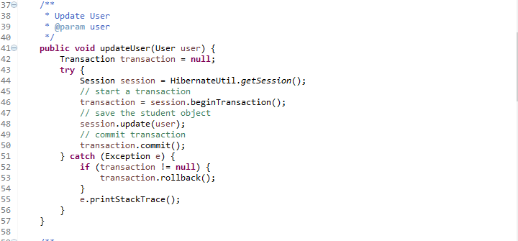

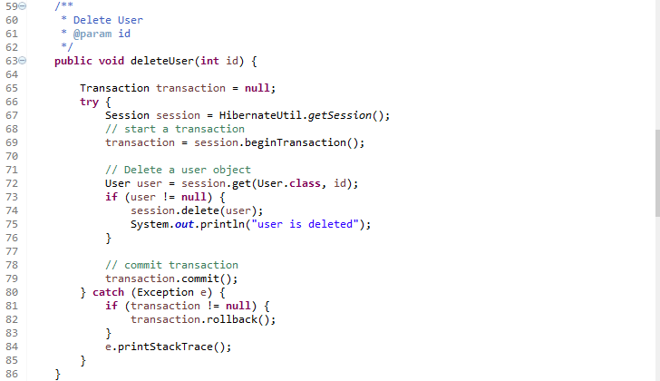

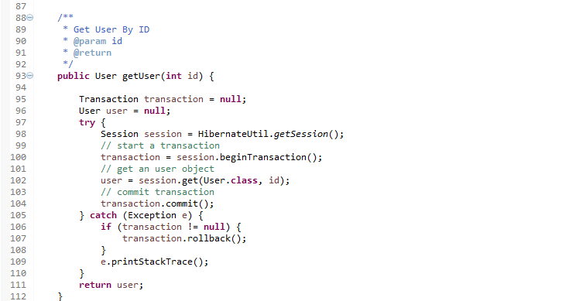

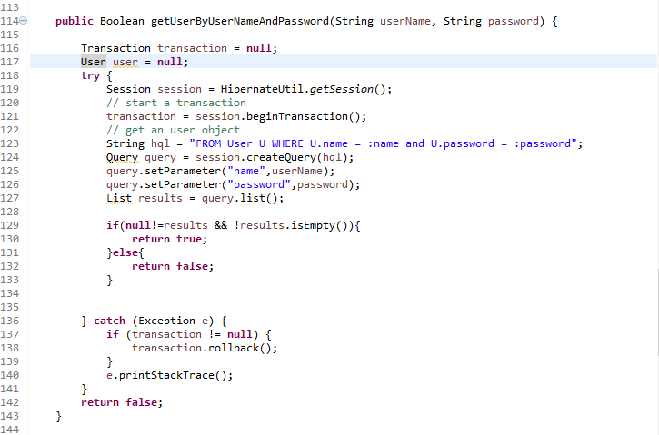

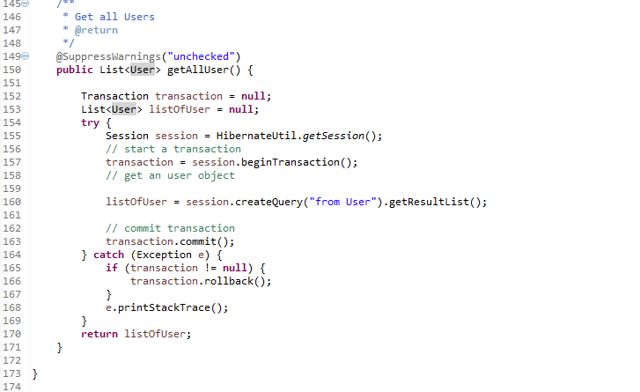

**Source Code:-com.swaraj.model 🡪1) Classes.java**

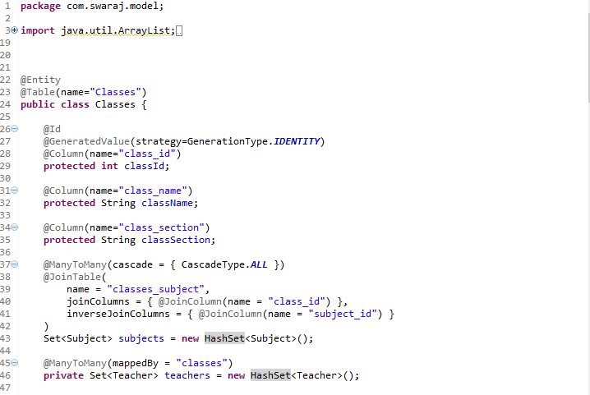

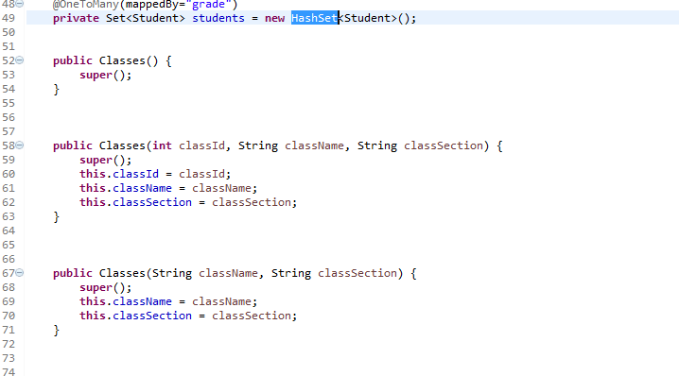

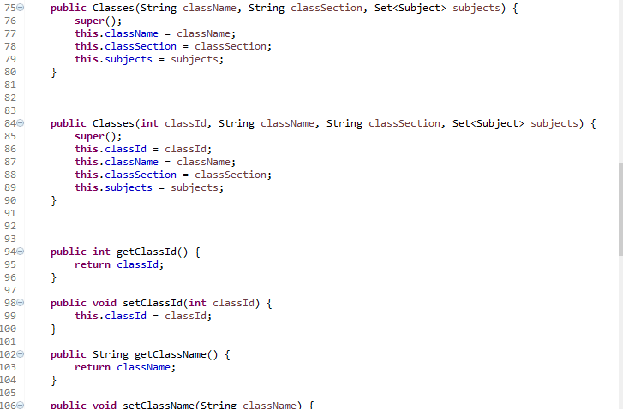

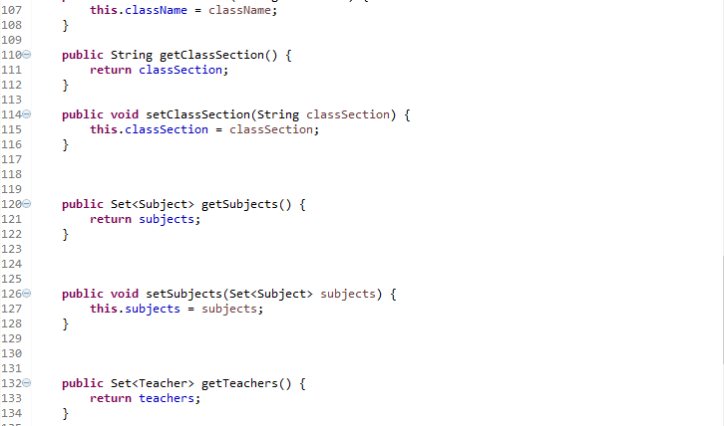

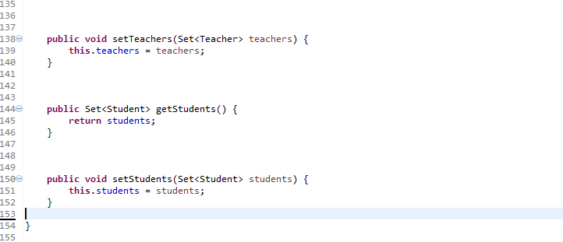

**Source Code:-com.swaraj.model 🡪2) Student.java**

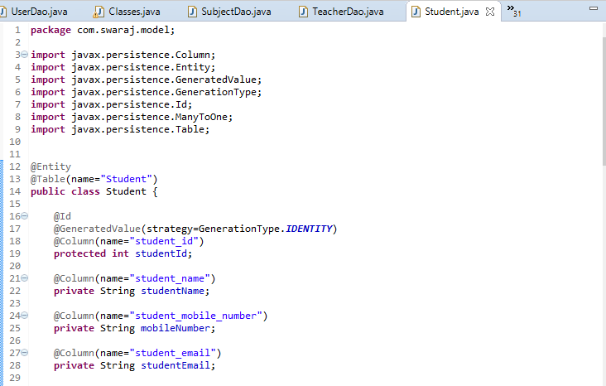

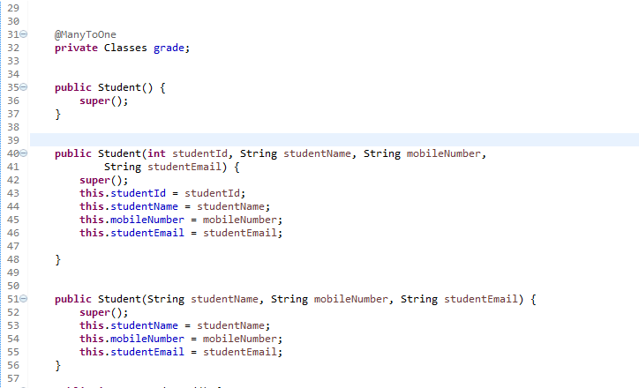

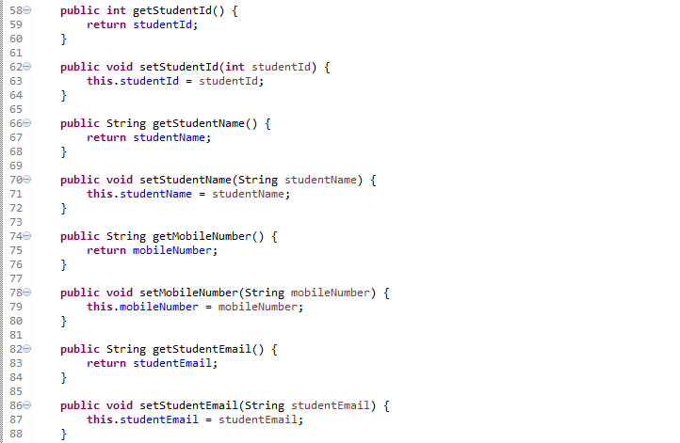

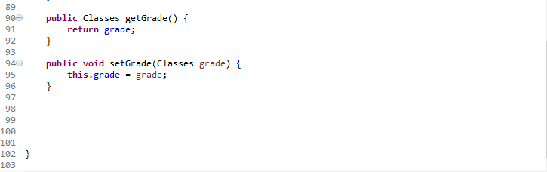

**Source Code:-com.swaraj.model 🡪3) Subject.java**

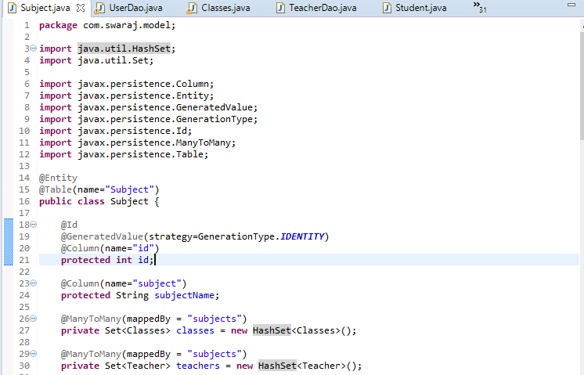

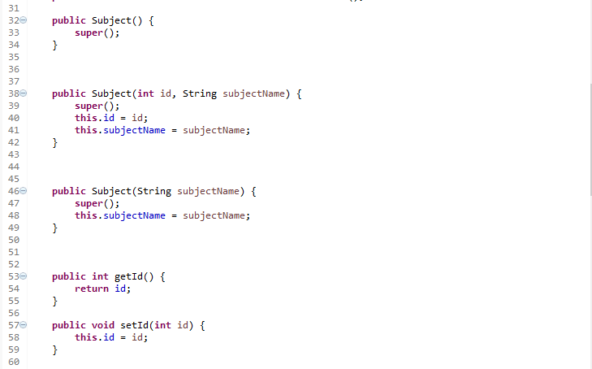

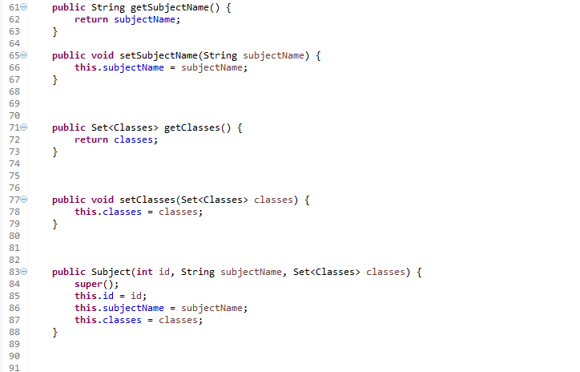

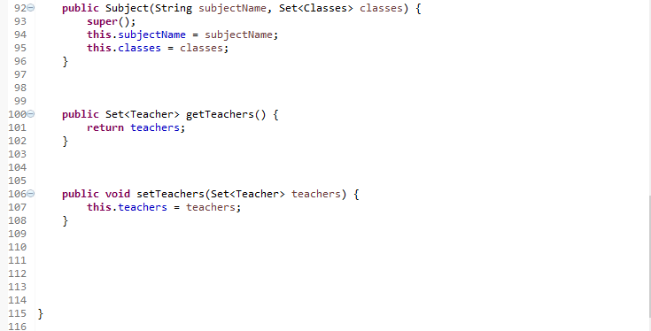

**Source Code:-com.swaraj.model 🡪4)Teacher.java**

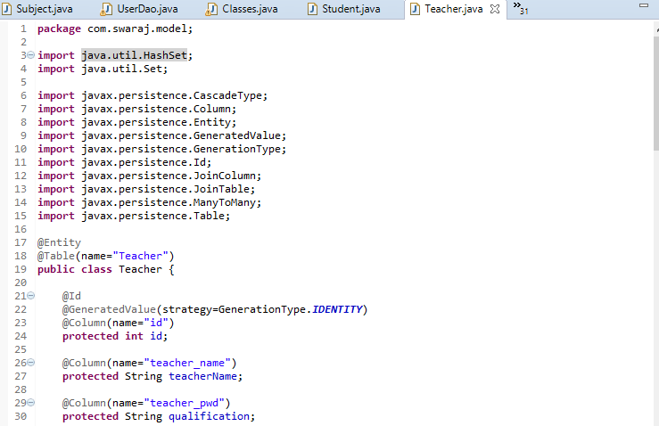

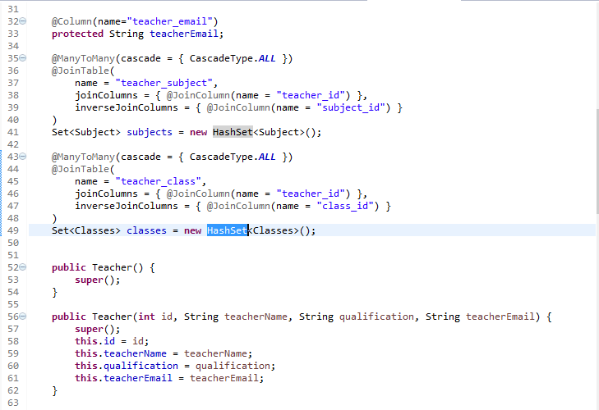

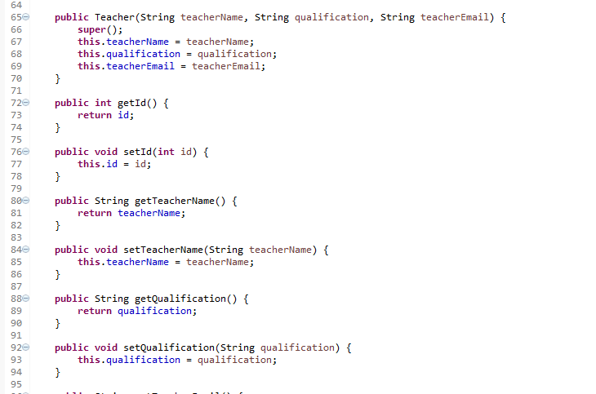

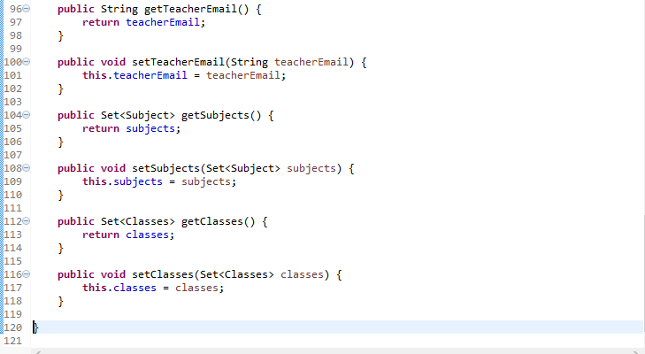

**Source Code:-com.swaraj.model 🡪5)User.java**

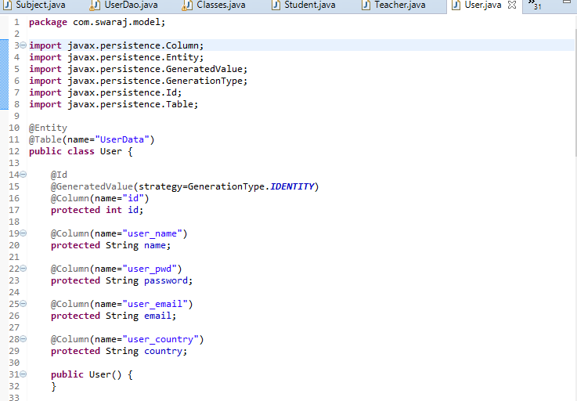

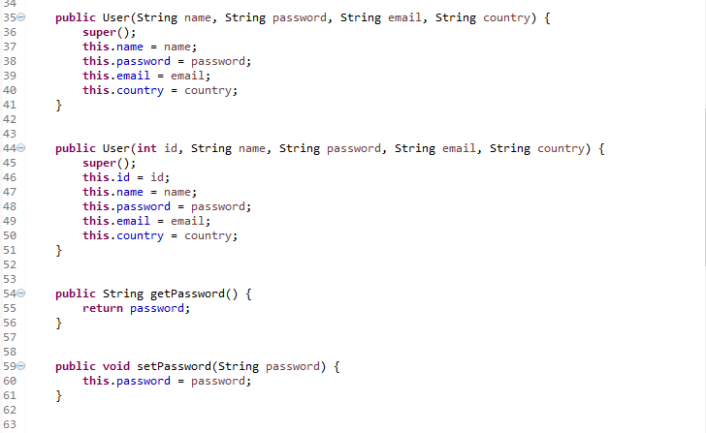

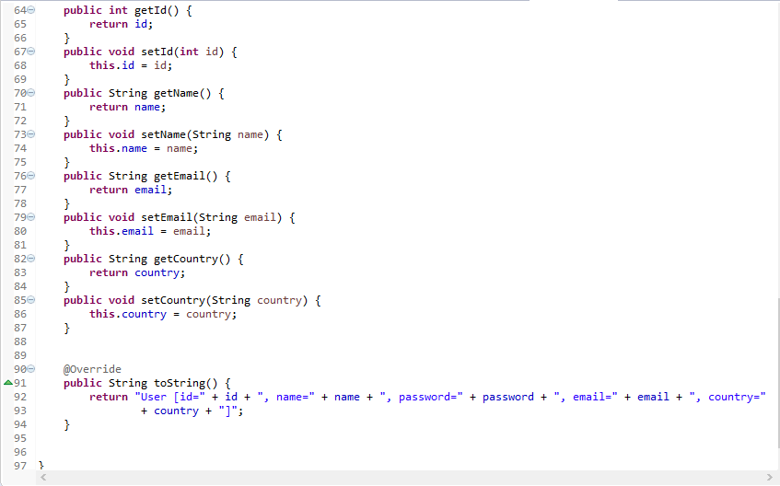

**Source Code:-com.swaraj.servlets 🡪1)ClassesServlet.java**

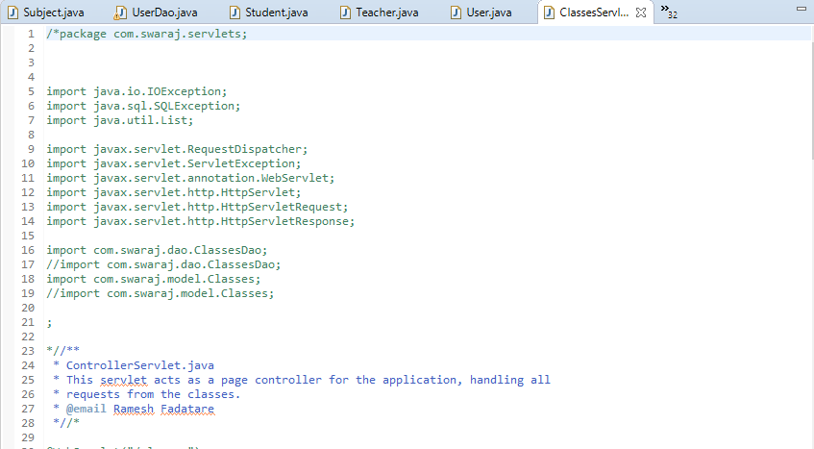

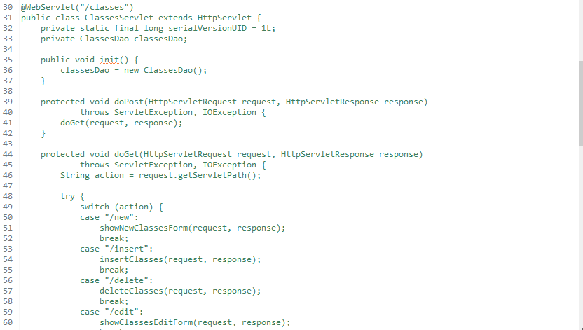

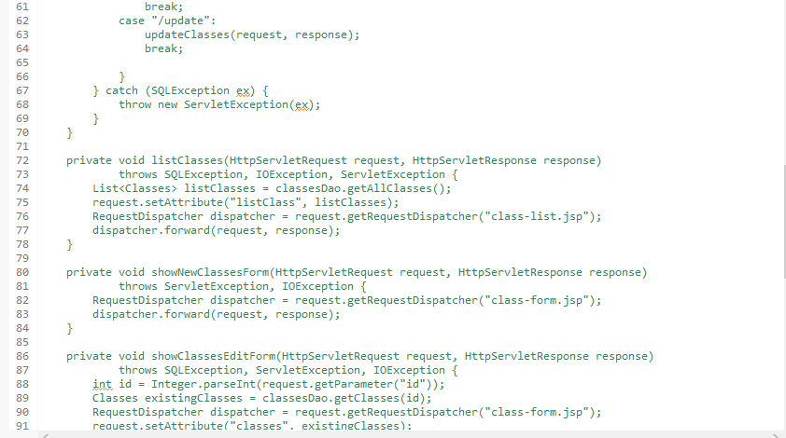

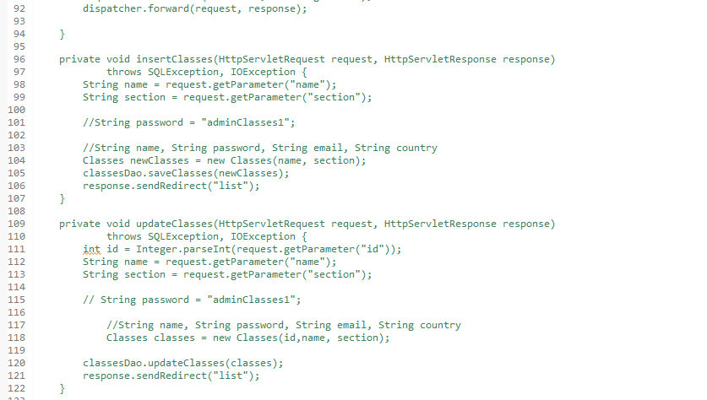

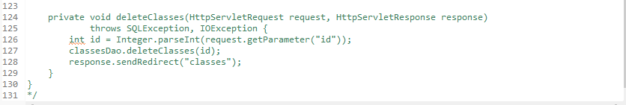

**Source Code:-com.swaraj.servlets 🡪2)StudentServlet.java**

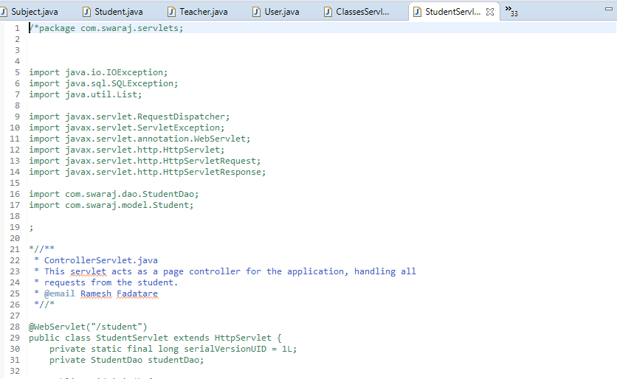

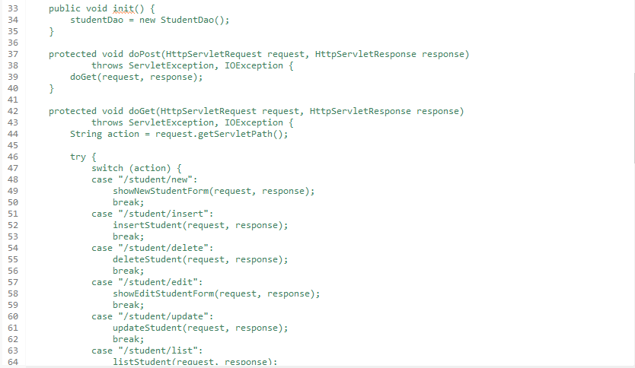

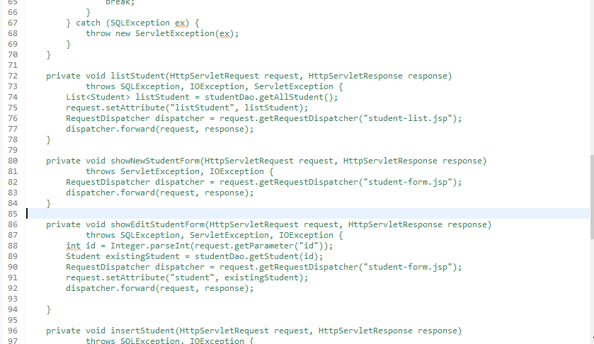

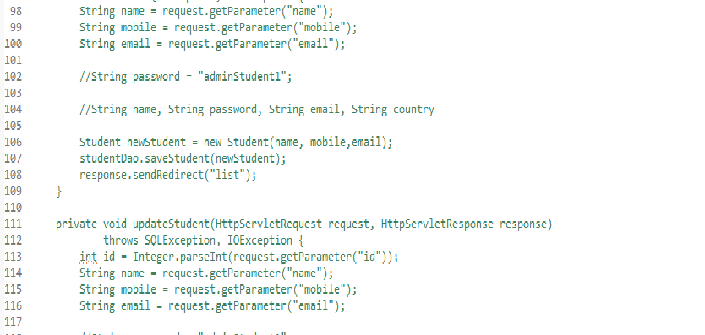

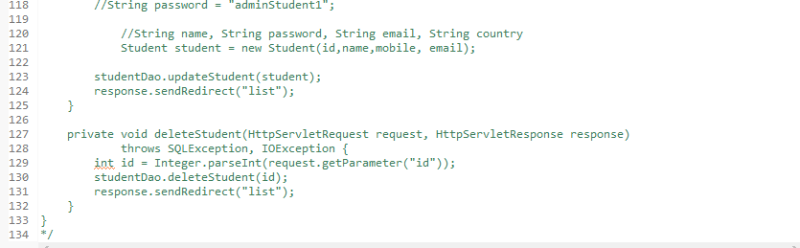

**Source Code:-com.swaraj.servlets 🡪3)SubjectServlet.java**

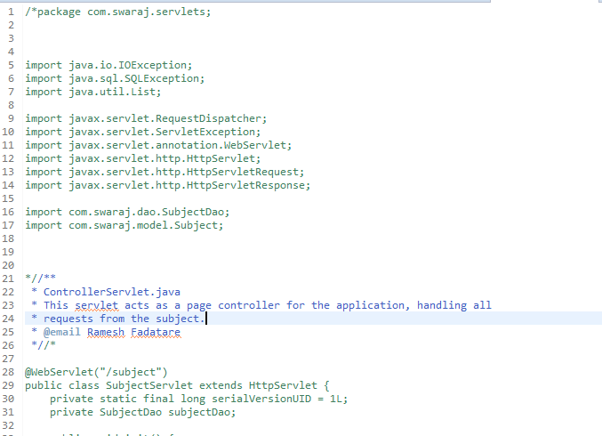 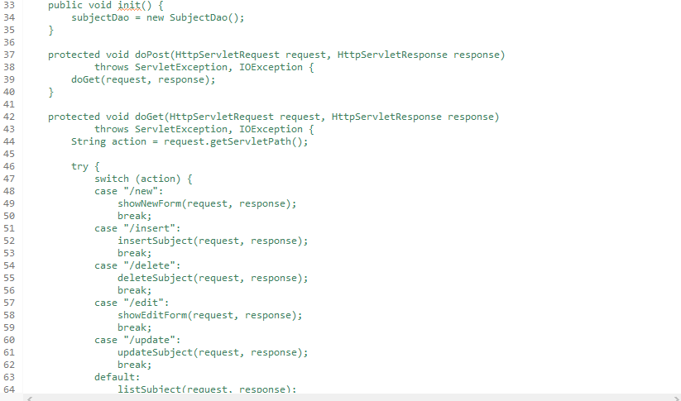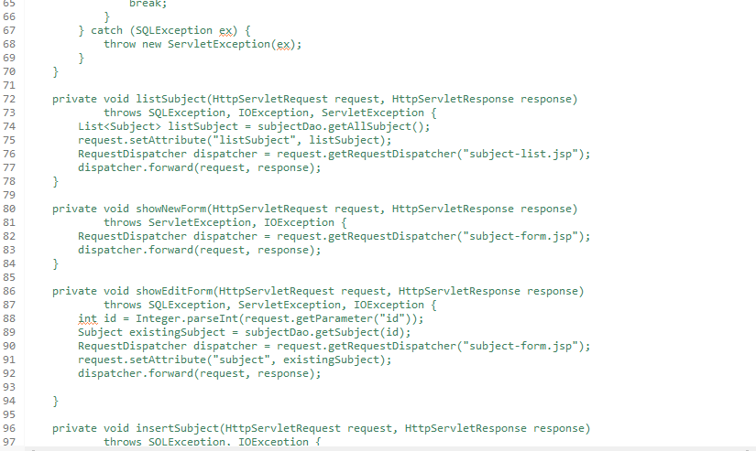 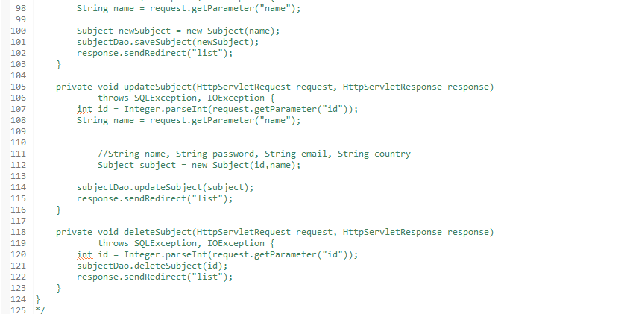

**Source Code:-com.swaraj.servlets 🡪4)TeacherServlet.java**

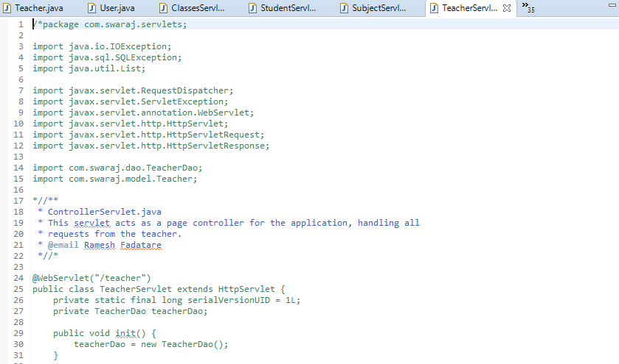

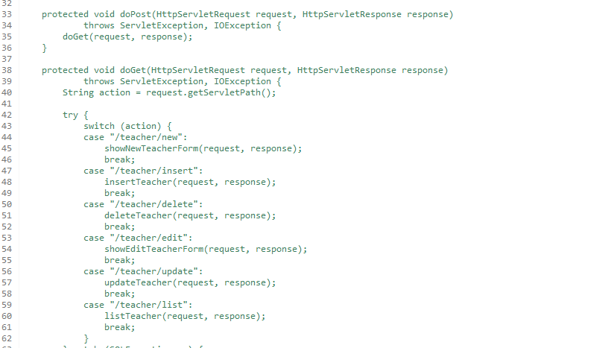

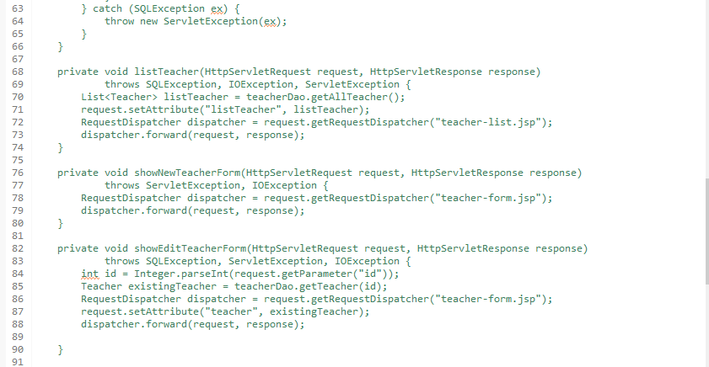

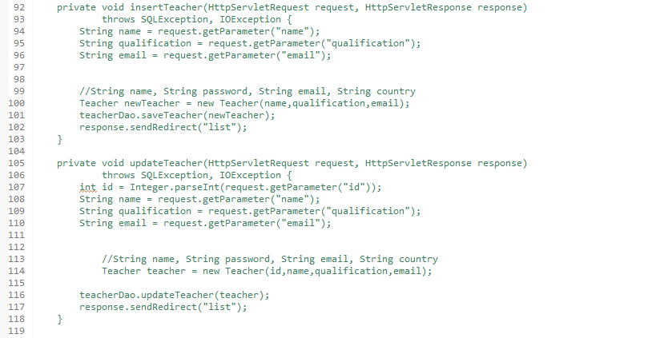

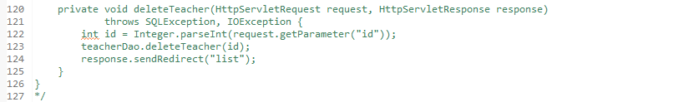

**Source Code:-com.swaraj.servlets 🡪5)UserServlet.java**

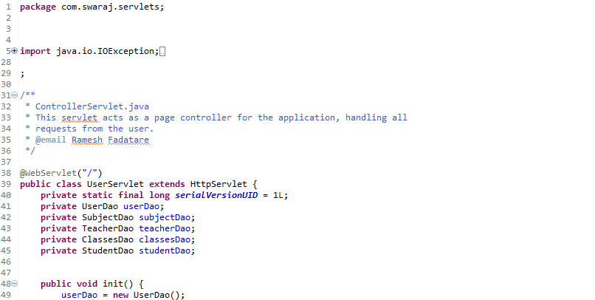

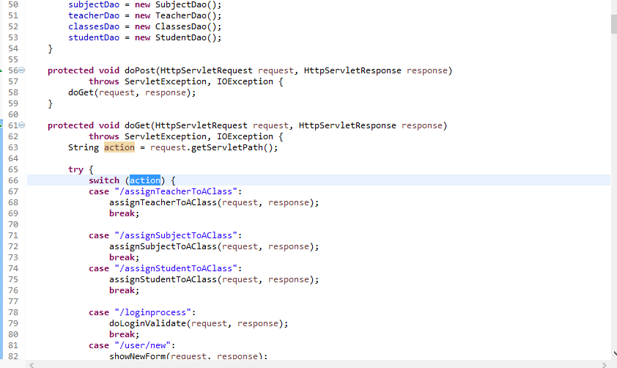

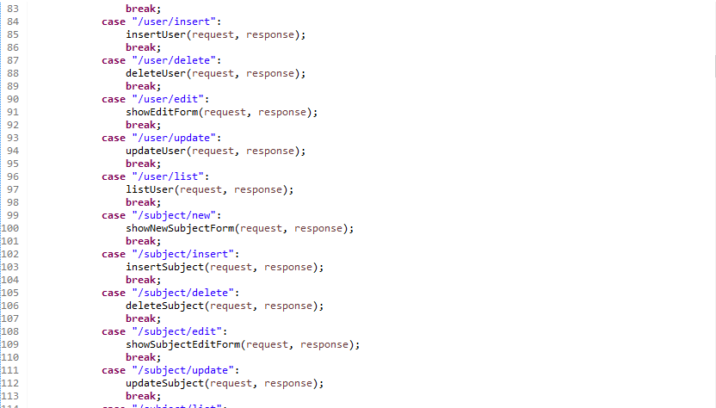

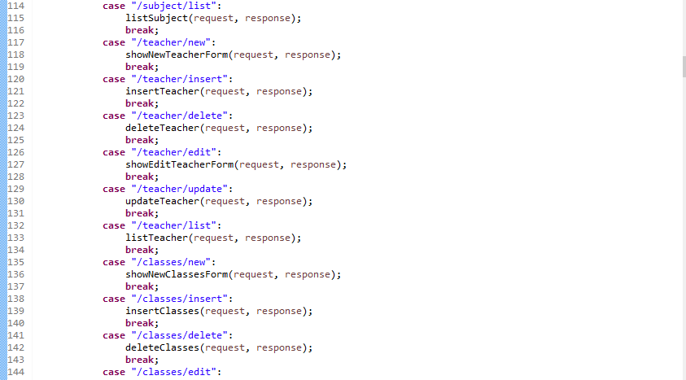

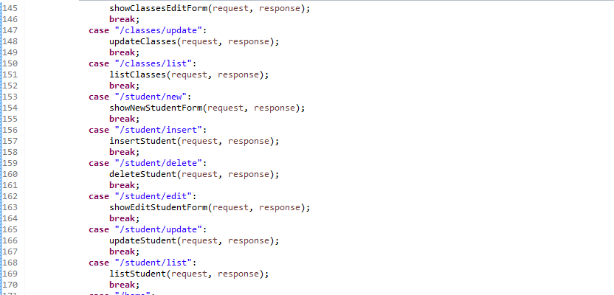

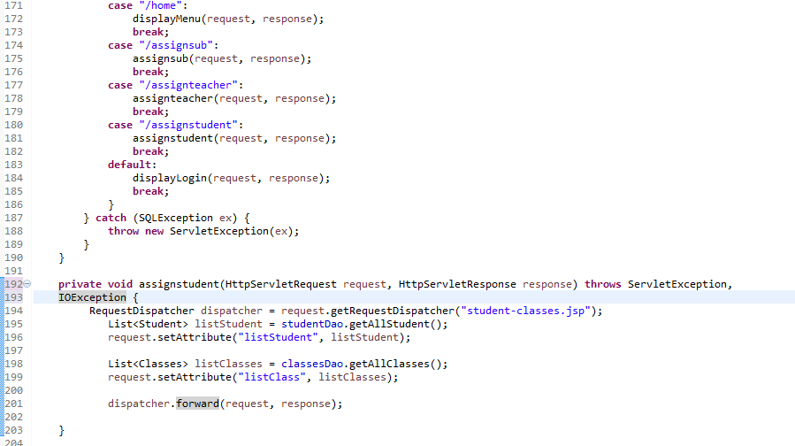

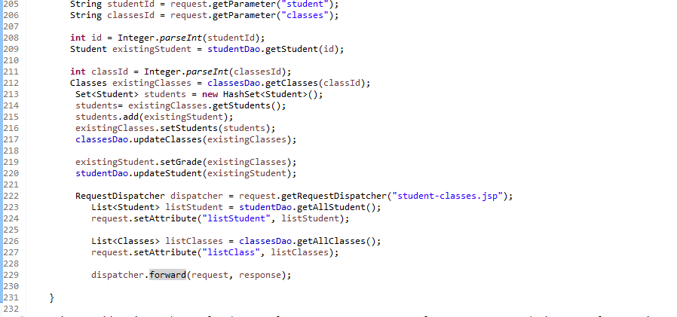

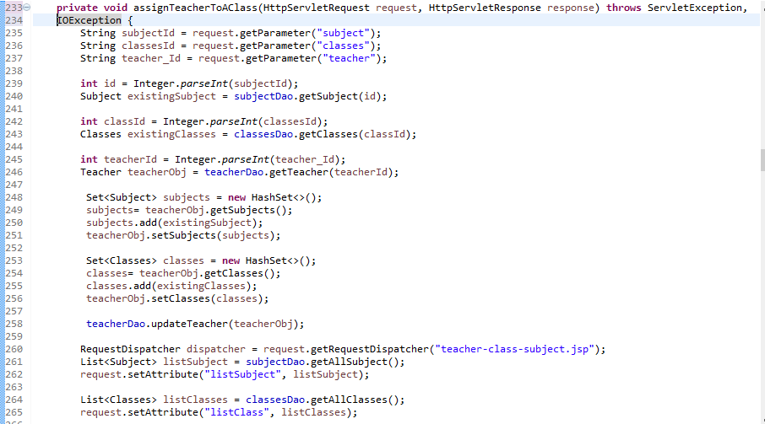

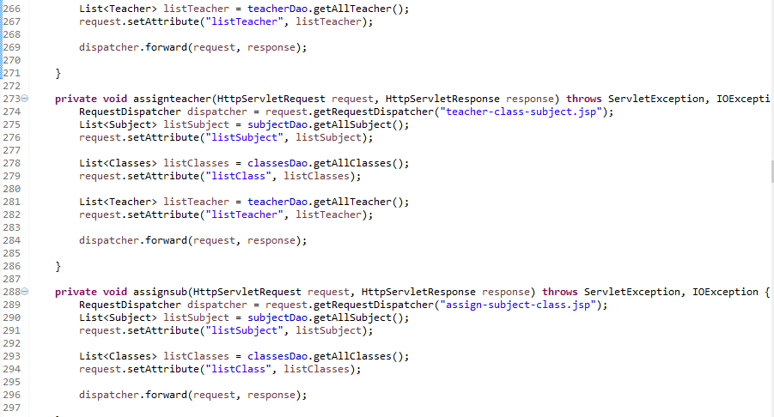

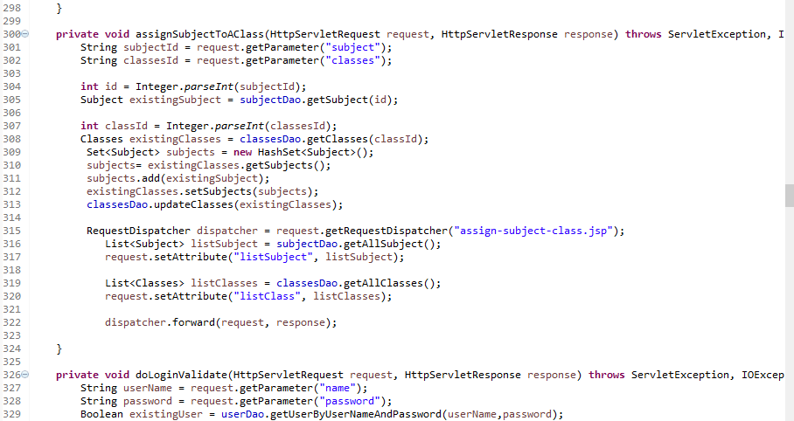

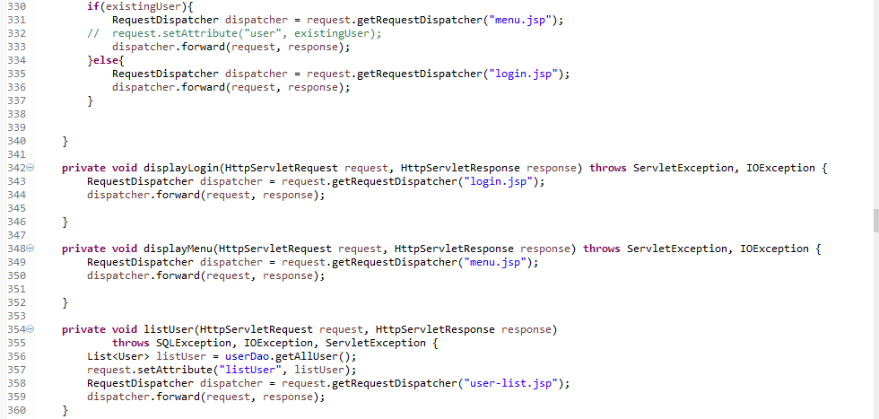

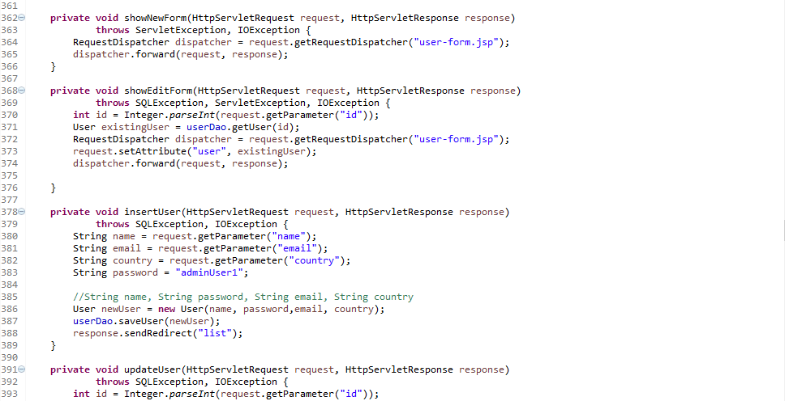

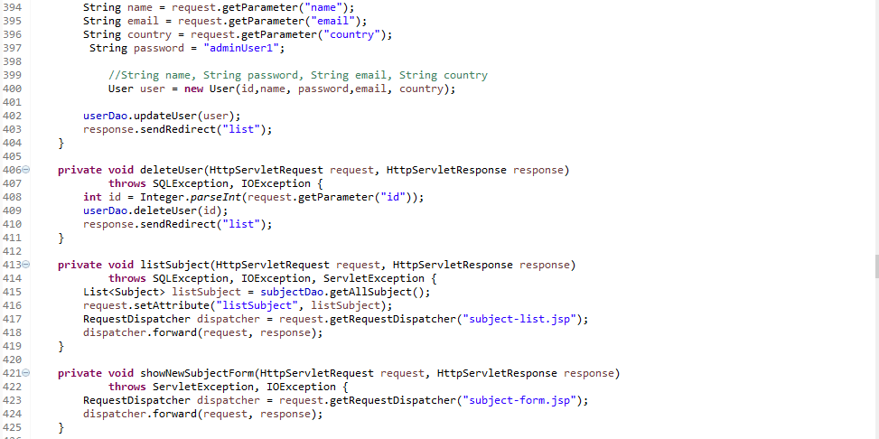

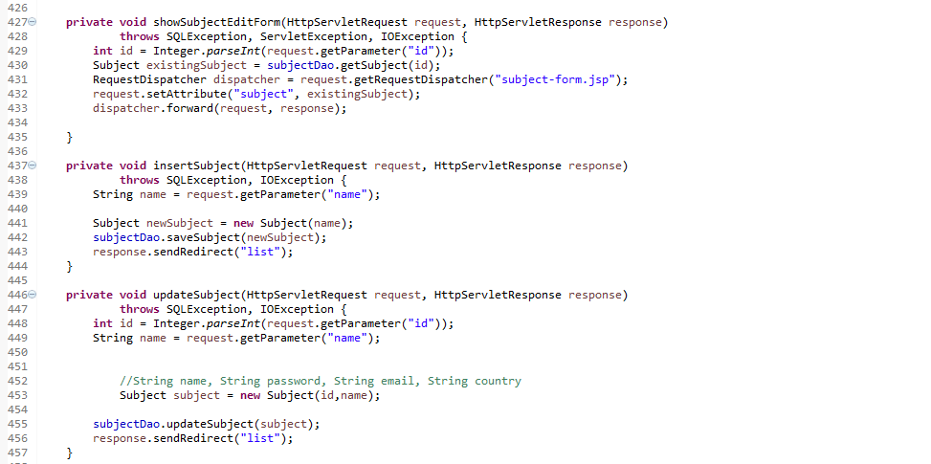

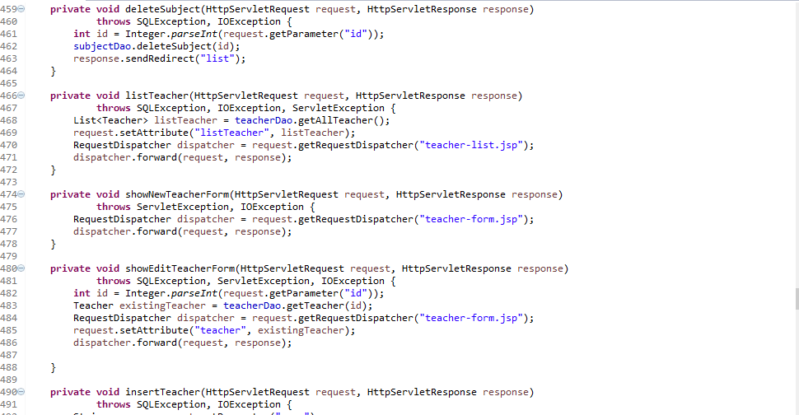

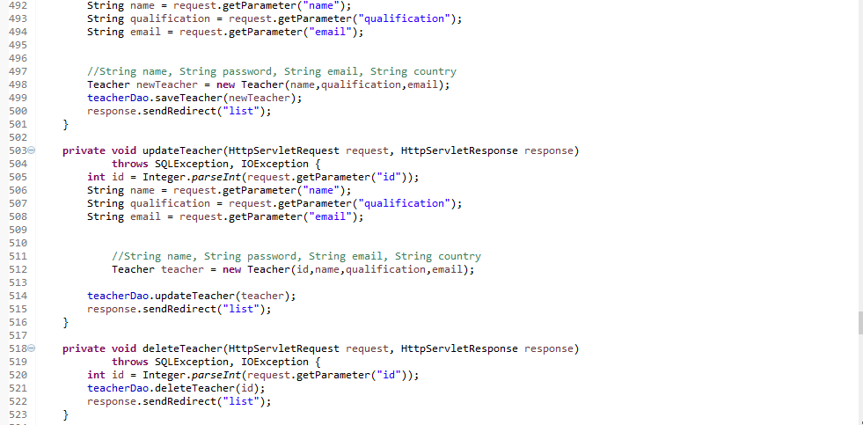

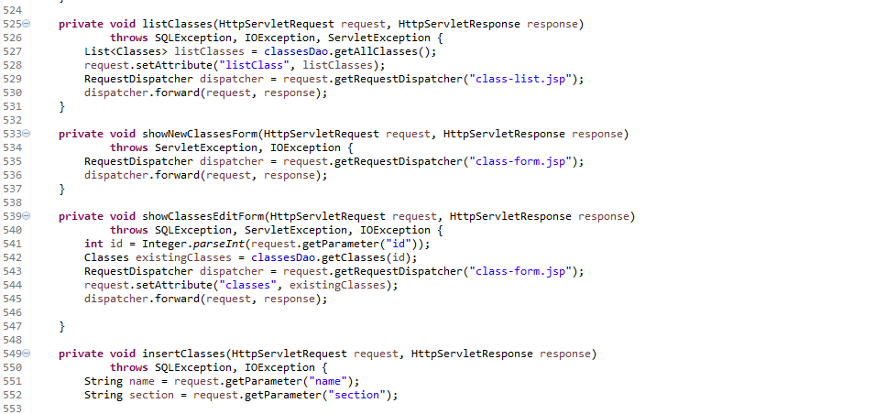

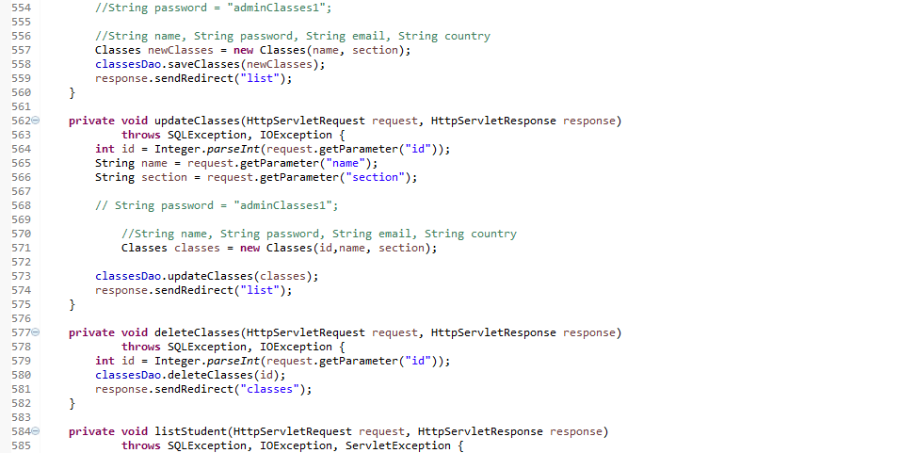

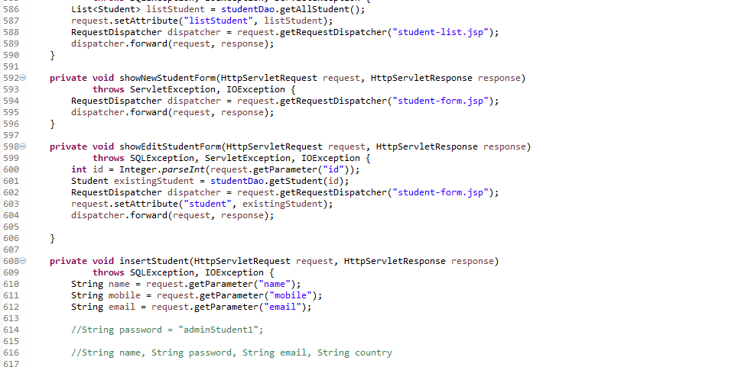

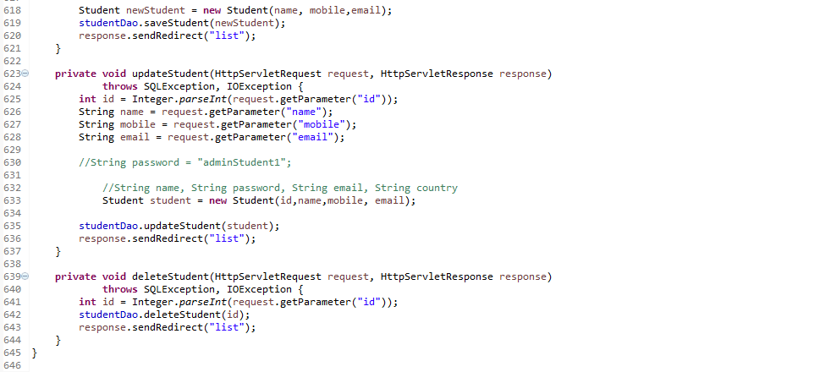

**Source Code:- WEBINF 🡪assign-subject-class.jsp**

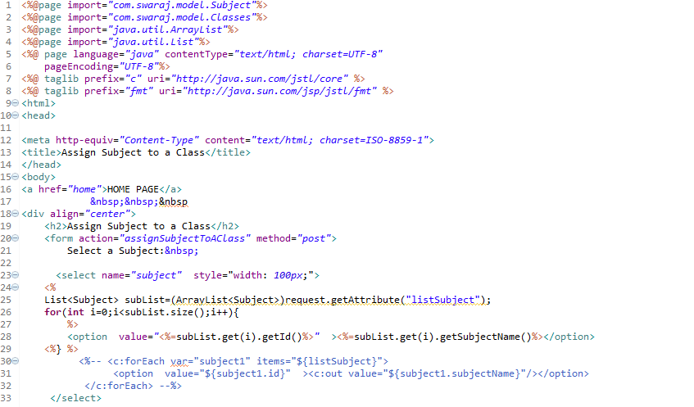

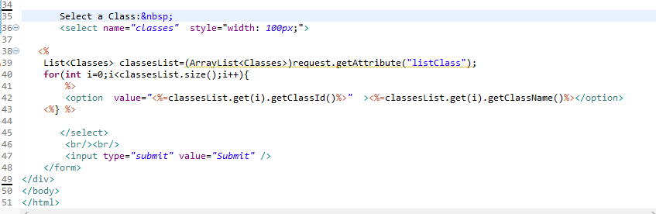

**Source Code:- WEBINF 🡪error.jsp**

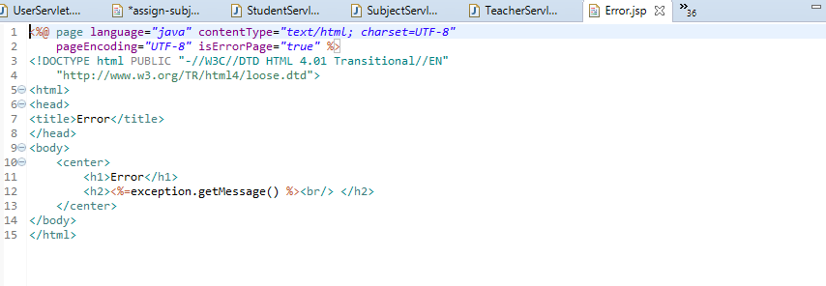

**Source Code:- WEBINF 🡪login.jsp**

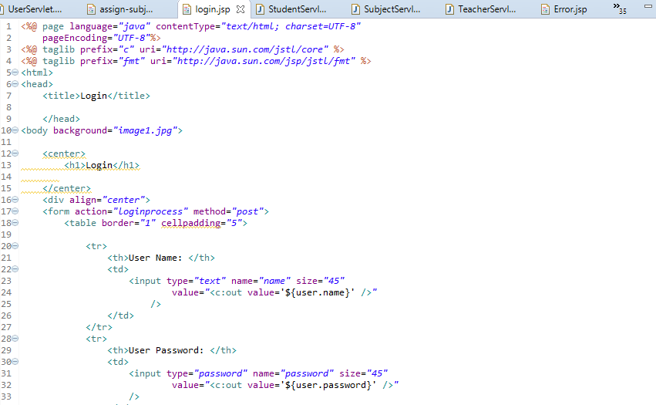

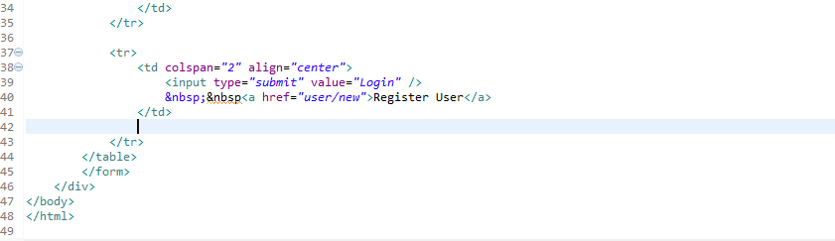

**Source Code:- WEBINF 🡪menu.jsp**

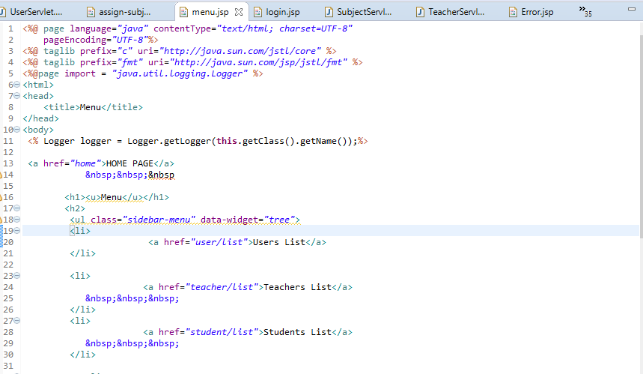

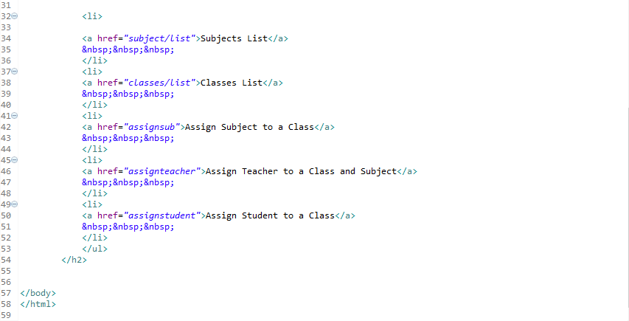

**Source Code:- WEBINF 🡪student-classes.jsp**

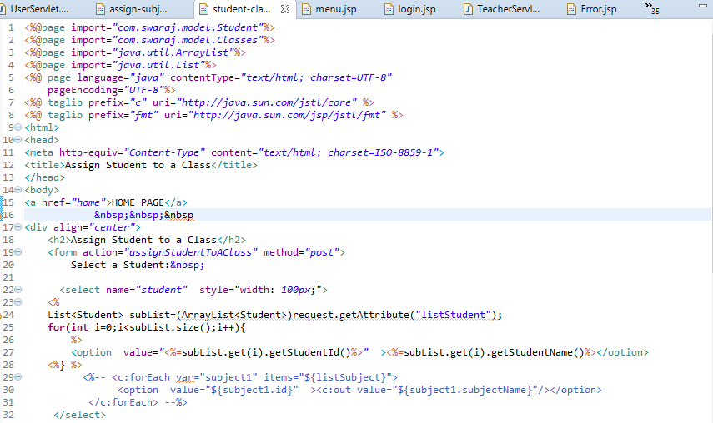

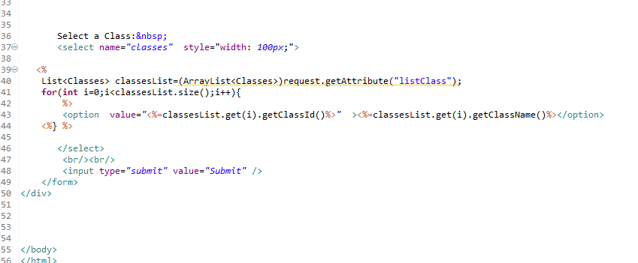

**Source Code:- WEBINF 🡪teacher-class-subject.jsp**

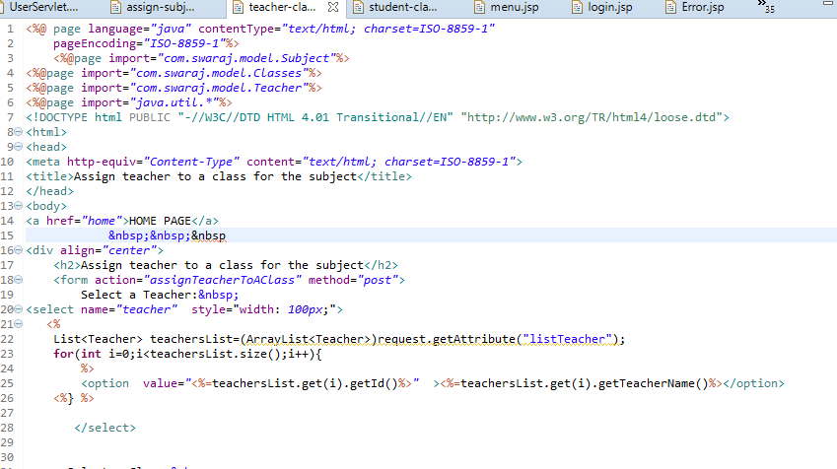

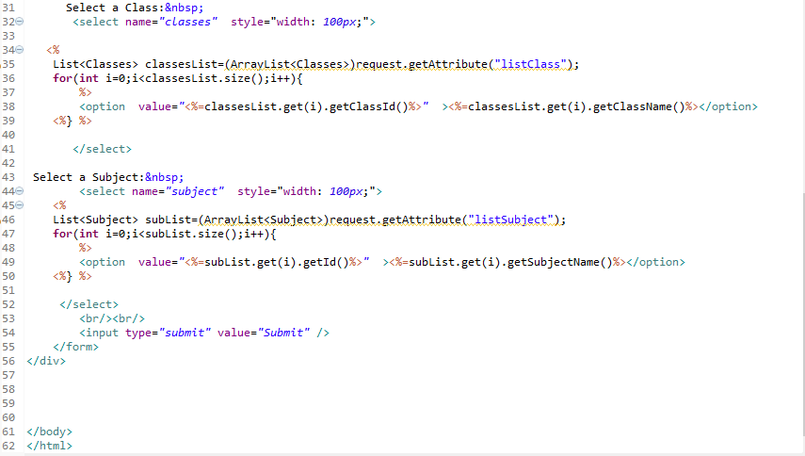

**Source Code:- WEBINF 🡪main.webapp.classes🡪class-form.jsp**

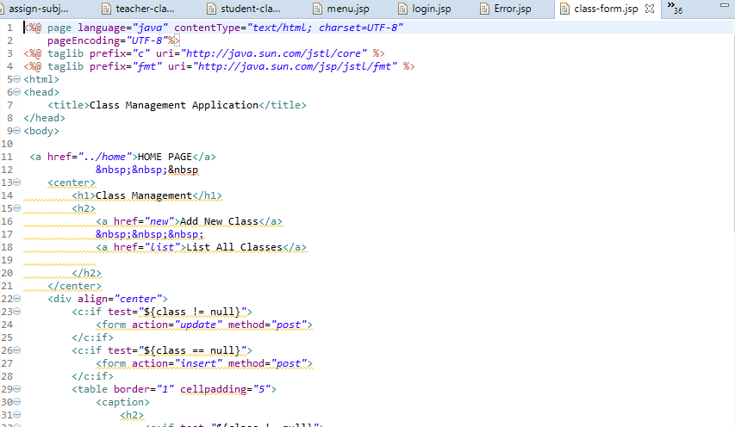

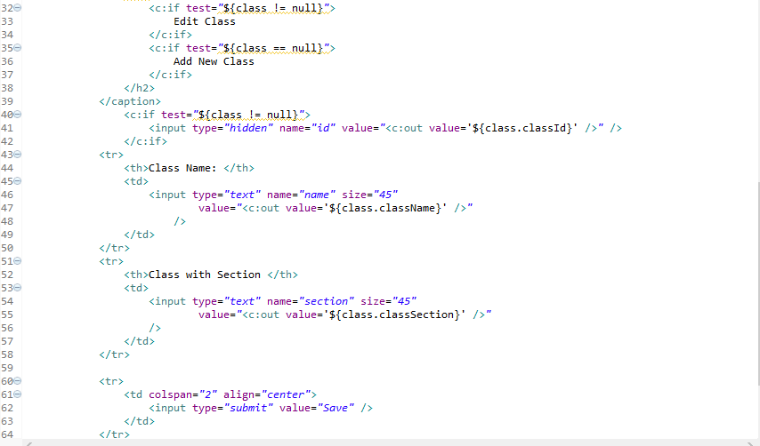

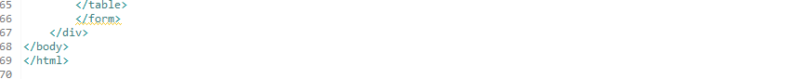

**Source Code:- WEBINF 🡪main.webapp.classes🡪class-list.jsp**

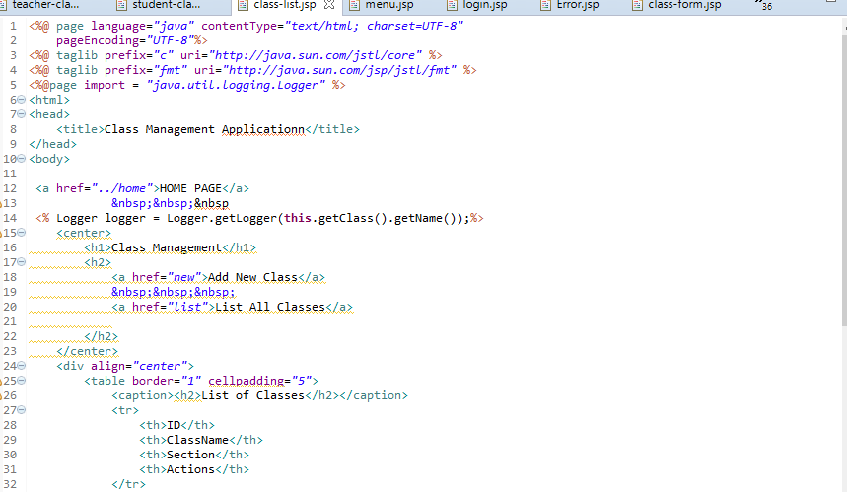

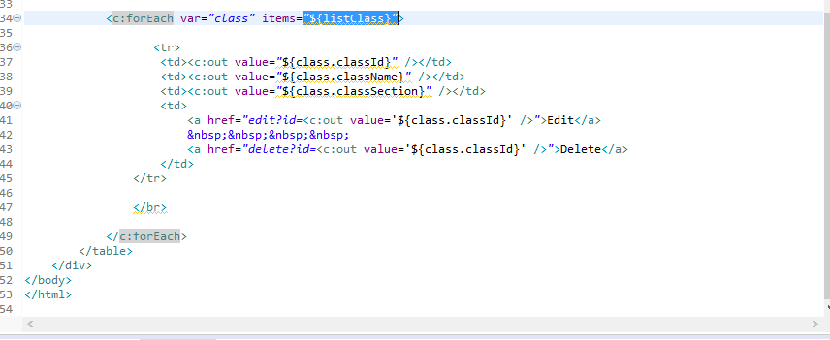

**Source Code:- WEBINF 🡪main.webapp.classes🡪class-report.jsp**

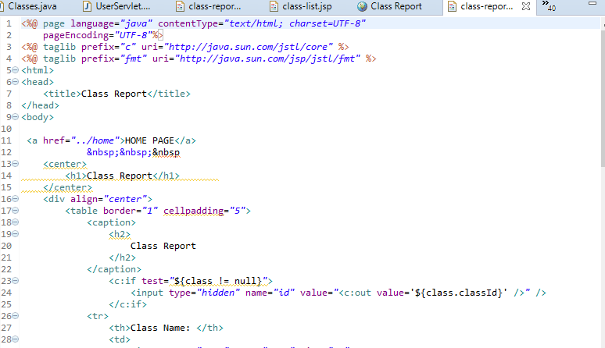

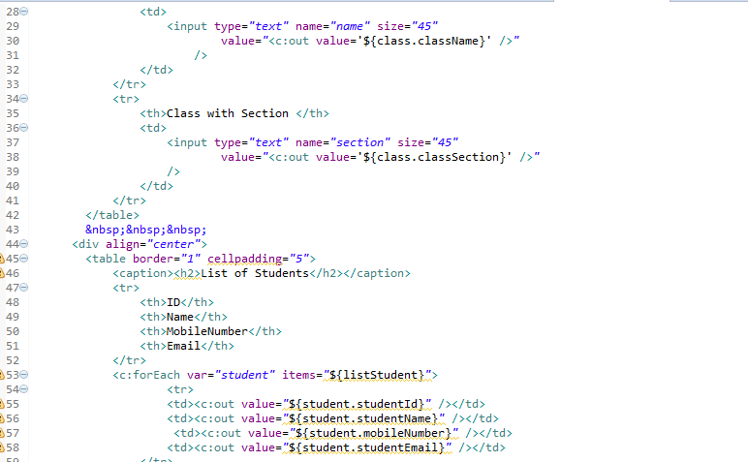

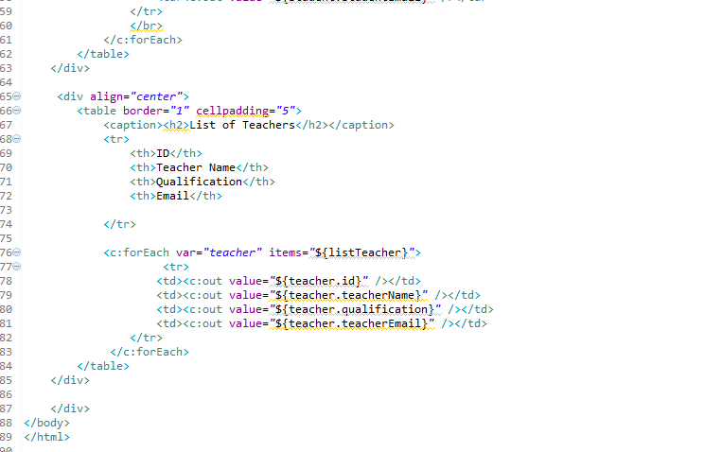

**Source Code:- WEBINF 🡪main.webapp.student🡪student-form.jsp**

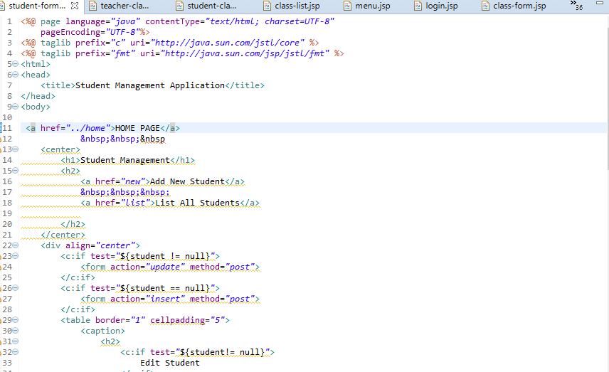

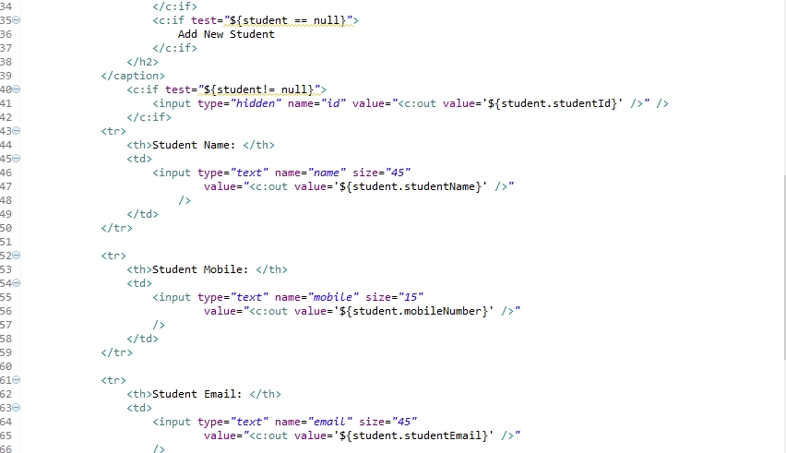

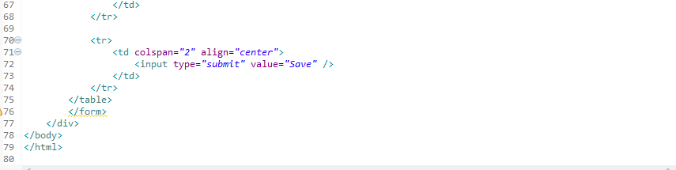

**Source Code:- WEBINF 🡪main.webapp.student🡪student-list.jsp**

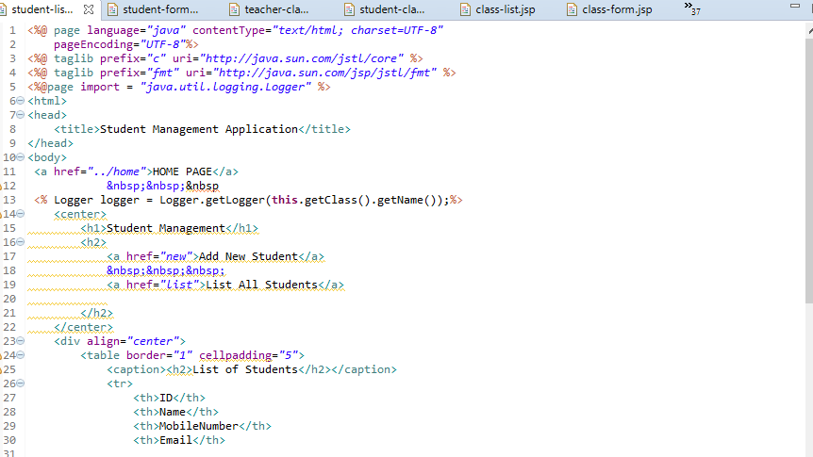

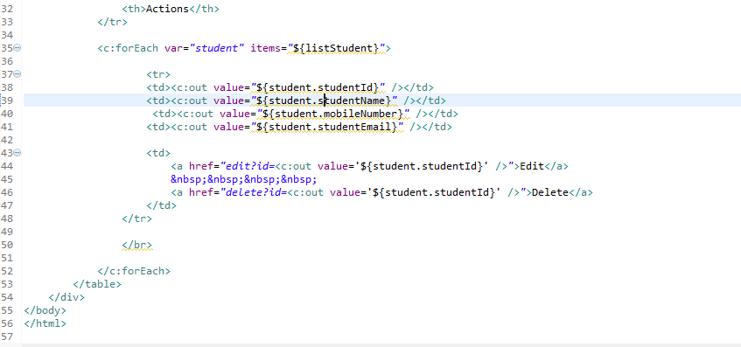

**Source Code:- WEBINF 🡪main.webapp.subject🡪subject-form.jsp**

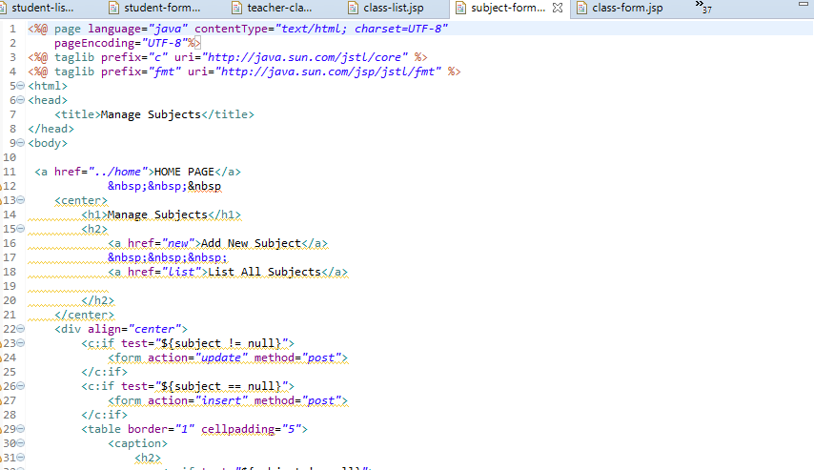

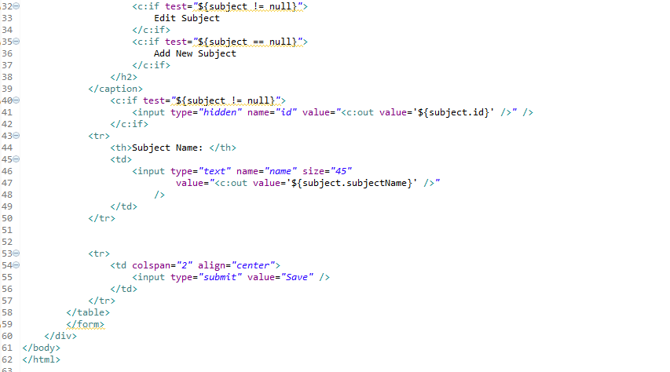

**Source Code:- WEBINF 🡪main.webapp.subject🡪subject-list.jsp**

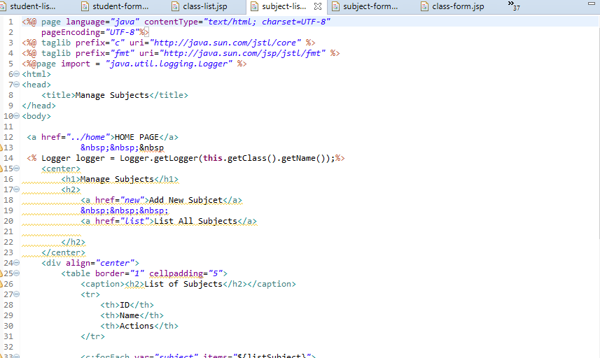

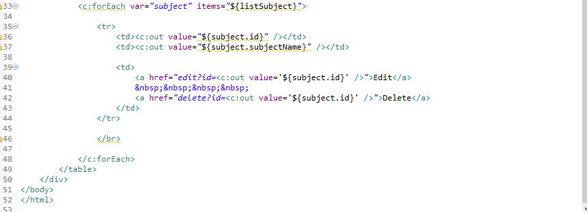

**Source Code:- WEBINF 🡪main.webapp.teacher🡪teacher-form.jsp**

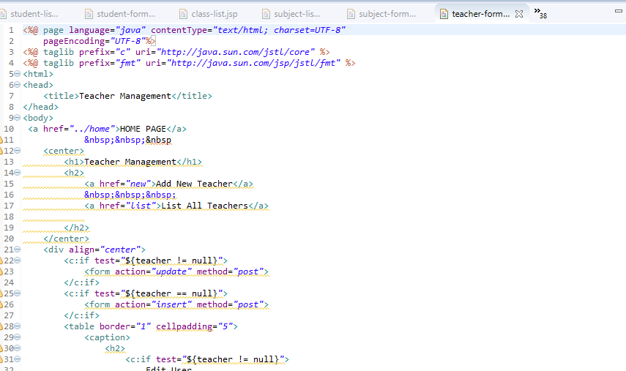

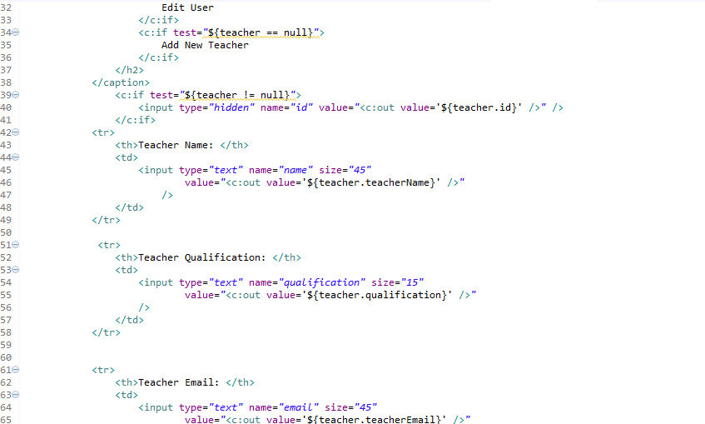

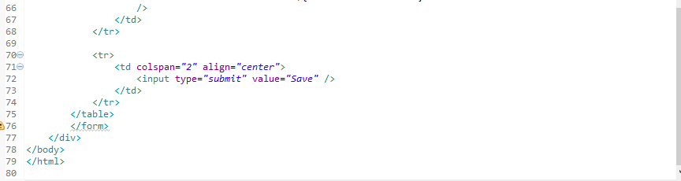

**Source Code:- WEBINF 🡪main.webapp.teacher🡪teacher-list.jsp**

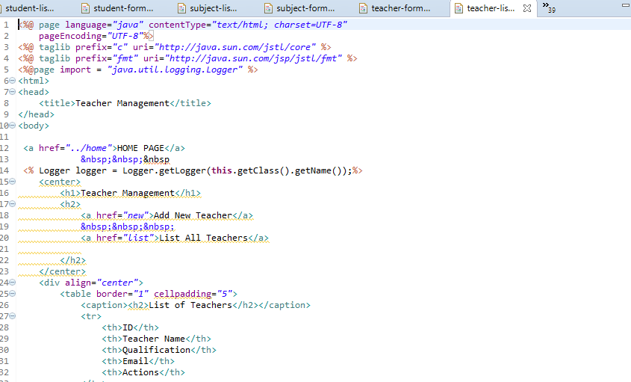

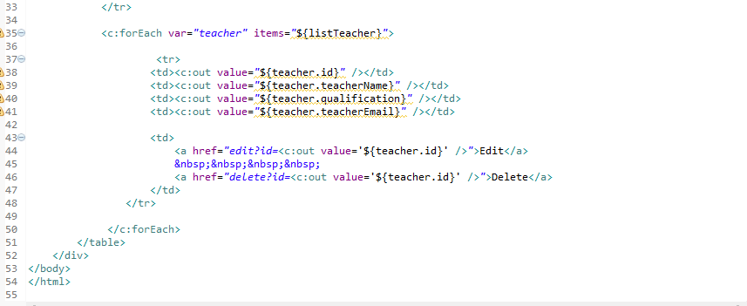

**Source Code:- WEBINF 🡪main.webapp.user🡪user-form.jsp**

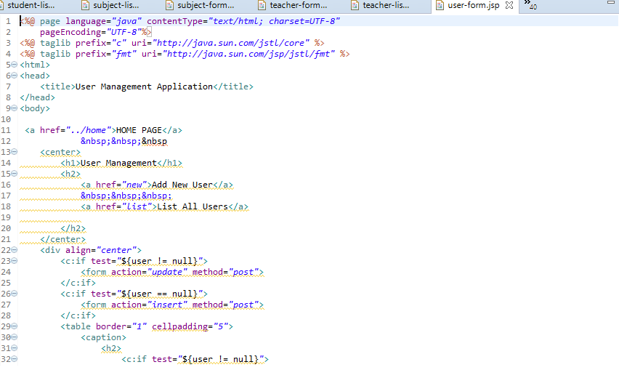

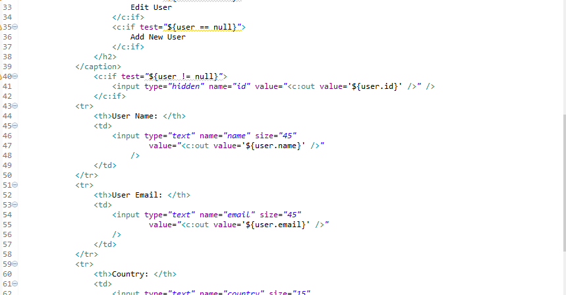

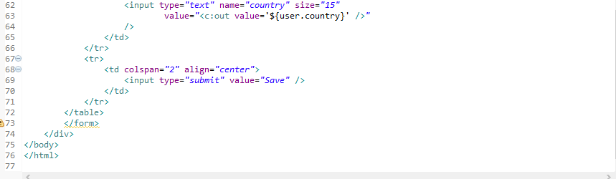

**Source Code:- WEBINF 🡪main.webapp.user🡪user-list.jsp**

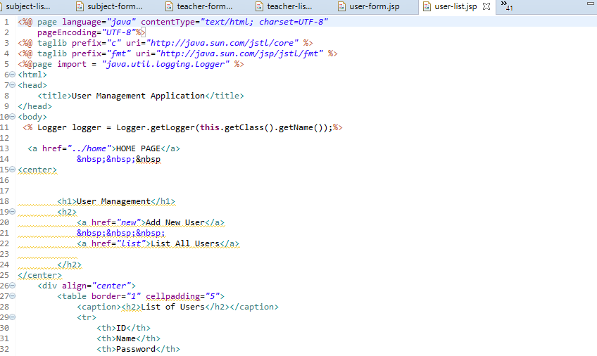

m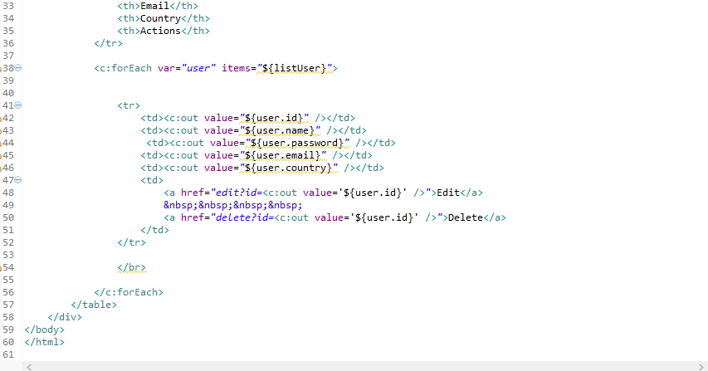

**Source Code:- METAINF 🡪Maven🡪SchoolManagement🡪com.swaraj🡪pom.xml**

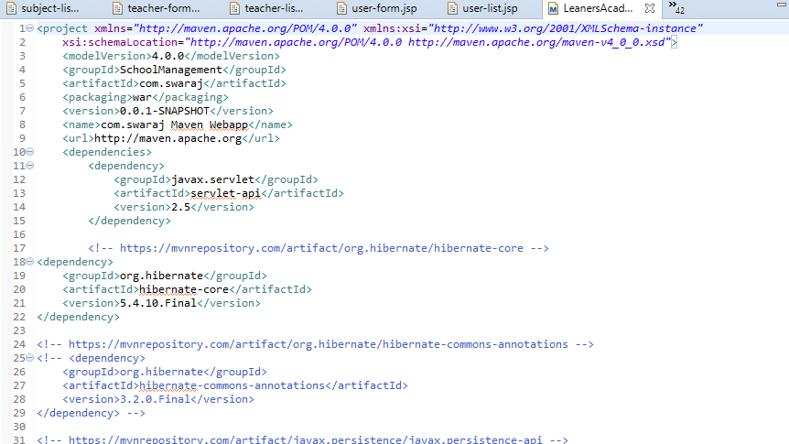

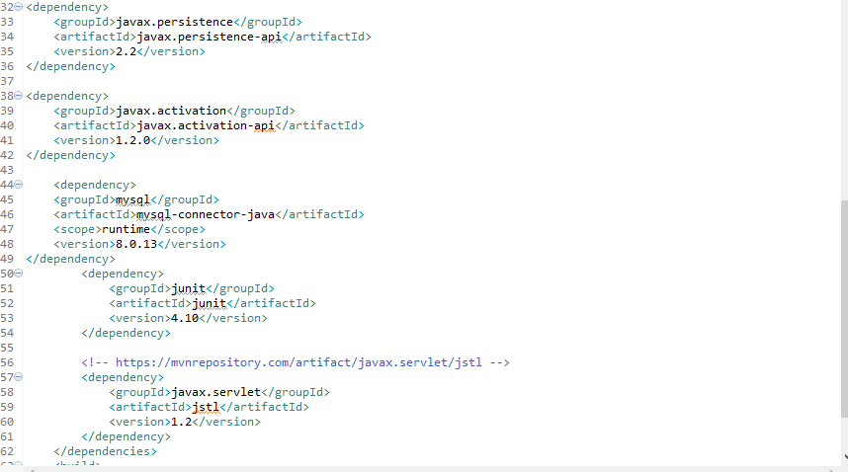



**Outputs-Screenshots:- Login Page shows username and user password**

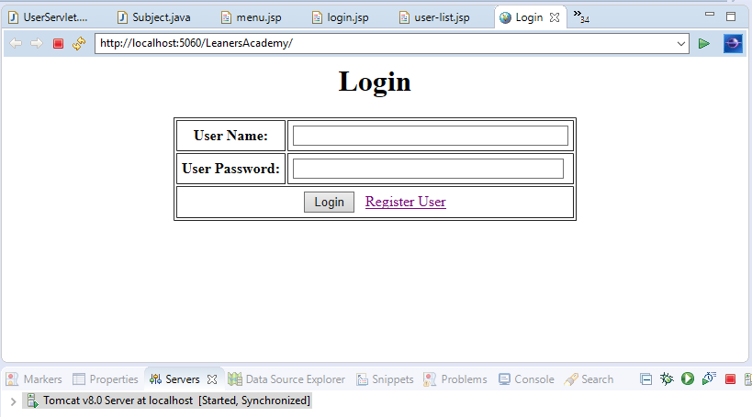

**Outputs-Screenshots:- Login Page, Click on Register User to register as a new user**

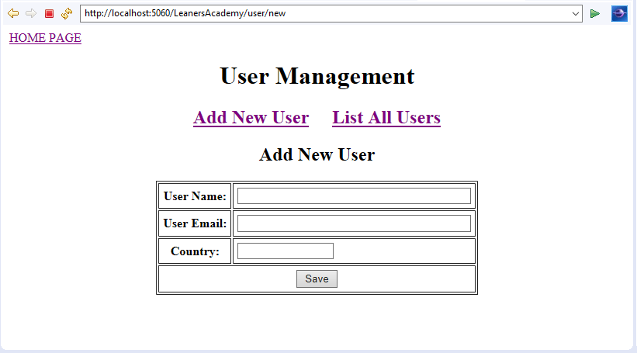

**Outputs-Screenshots:- Enter User Details and click save button**

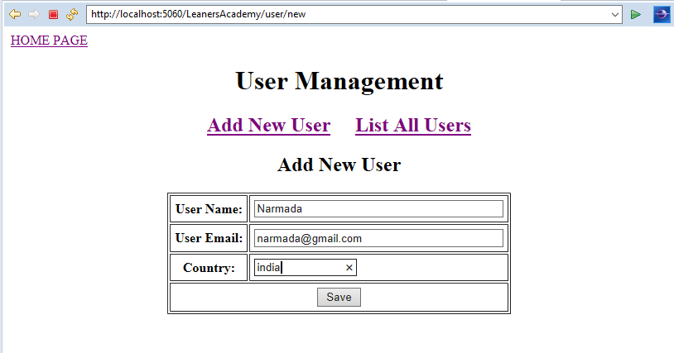

**Outputs-Screenshots:- On Successful registration, shows the List of users**

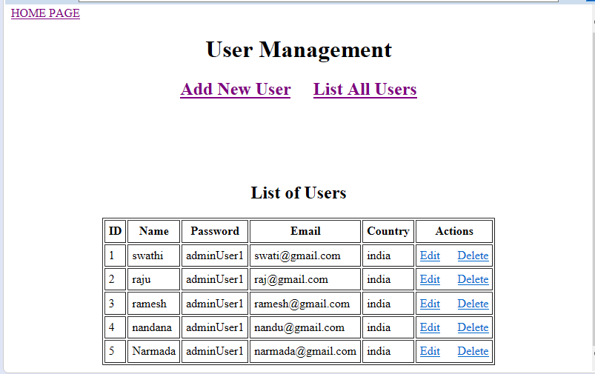

**Outputs-Screenshots:- Click on Home button to go to login page**



**Outputs-Screenshots:- Login Page –enter username and password and click login button**

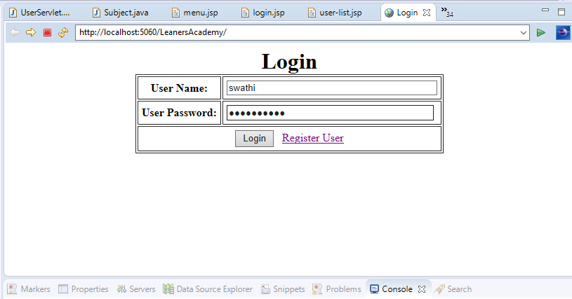

**Outputs-Screenshots:- Click Home Button to go back Menu Options**

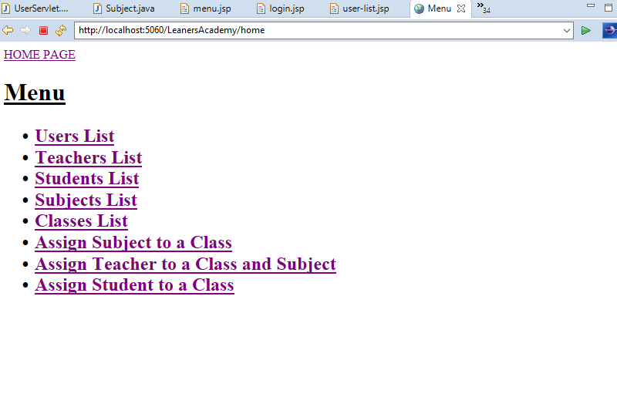

**Outputs-Screenshots:- Click on User’s List to check List of users**



**Outputs-Screenshots:- Click on add new user to add the new user**



**Outputs-Screenshots:- After successful register it will redirect to users list**



**Outputs-Screenshots:- To edit a new user click on edit button**

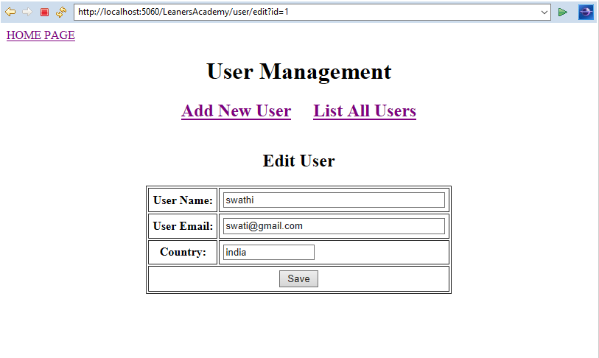

**Outputs-Screenshots:- On successful update it will redirect to List of users**



**Outputs-Screenshots:- To delete the user click on delete option🡪 after removing record 4, page will refresh the data**

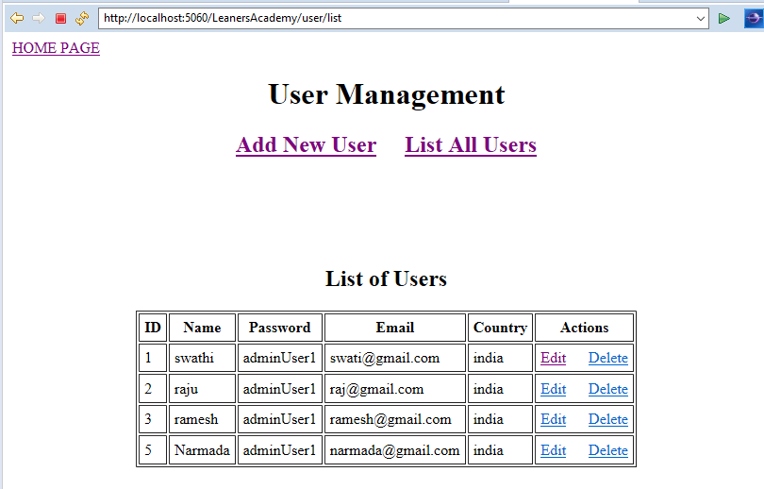

**Outputs-Screenshots:- Click Home Button to go back to Menu Options**



**Outputs-Screenshots:- Click on teachers list to display Teacher Management window**

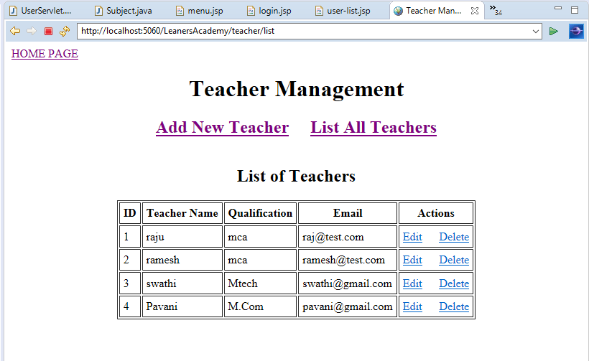

**Outputs-Screenshots:- Click on Add new teacher to add a new teacher to the list**

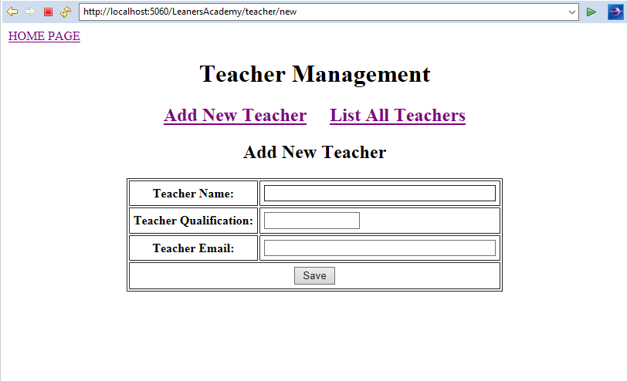

**Outputs-Screenshots:- Provide teacher details and click on save button**

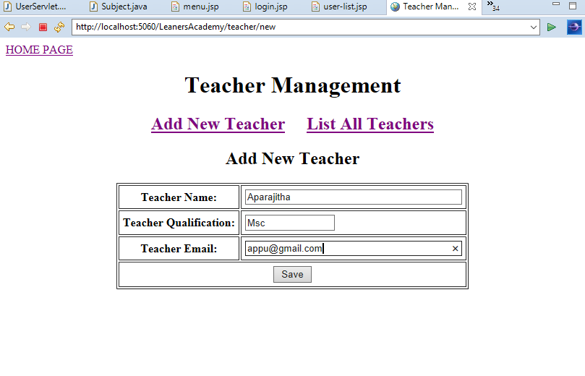

**Outputs-Screenshots:- After saving teacher details will redirect to teacher’s list page**

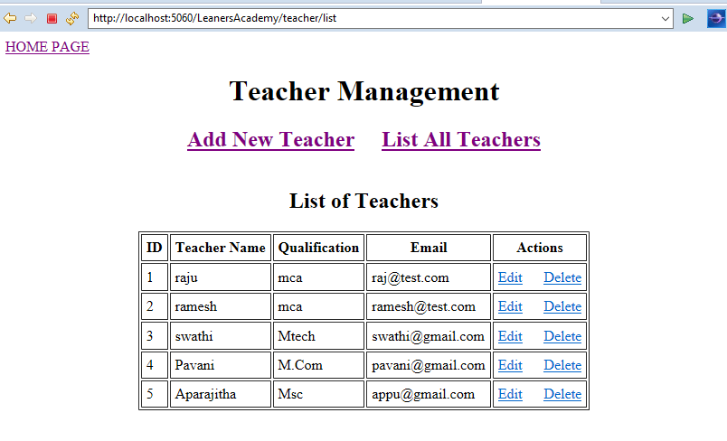

**Outputs-Screenshots:- Click on edit button to edit any teacher details**

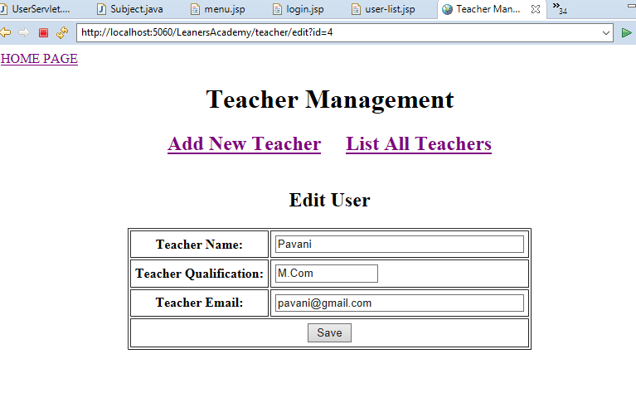

**Outputs-Screenshots:- After updating the teacher details it redirects to teacher’s list**



**Outputs-Screenshots:- click delete button to delete any teacher details-once user deleted the teacher, it will refresh the data- deleted the record from the list.**

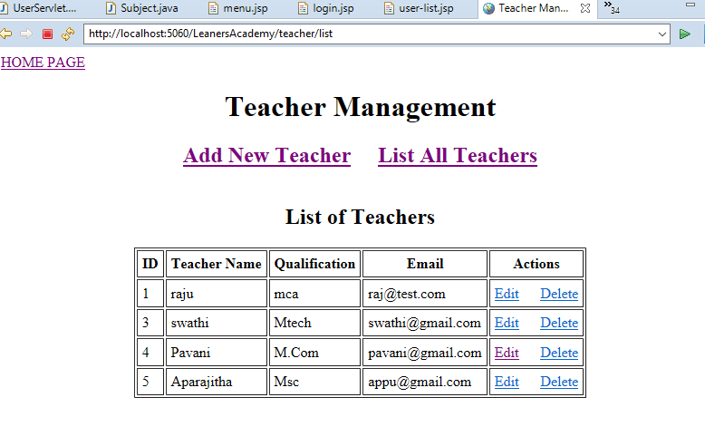

**Outputs-Screenshots:- Click Home Button to go back to Menu Options**



**Outputs-Screenshots:- Click on students list** **to display Student Management window**

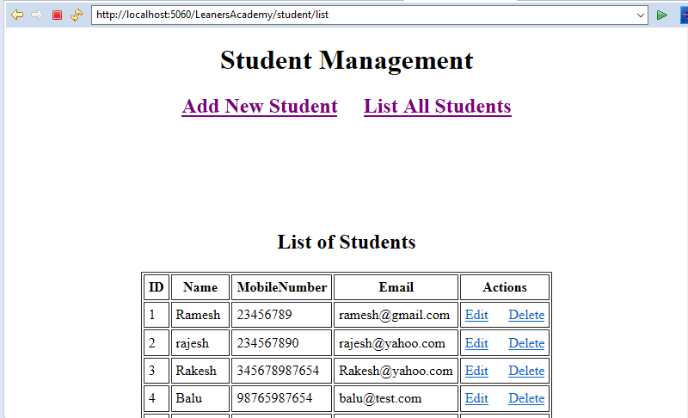

**Outputs-Screenshots:- Click on add new students to add new student**

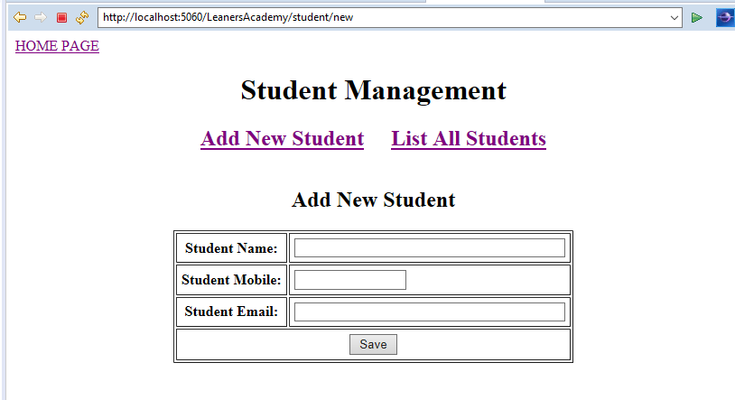

**Outputs-Screenshots:- Provide the student details and click on save button**

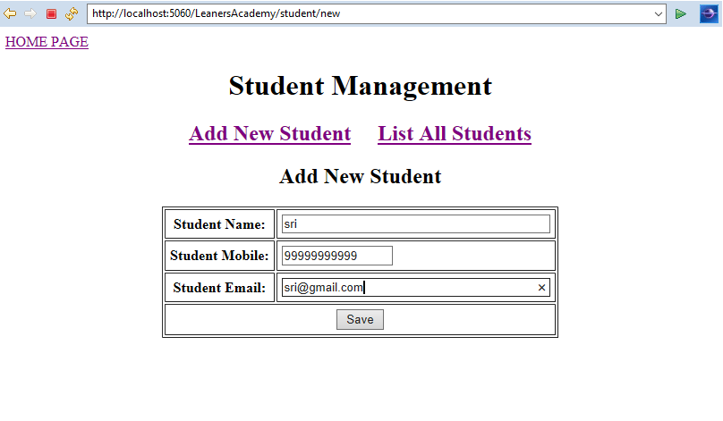

**Outputs-Screenshots:- After successful registration it will redirect to students list page**



**Outputs-Screenshots:- Click on edit button to edit the student details**

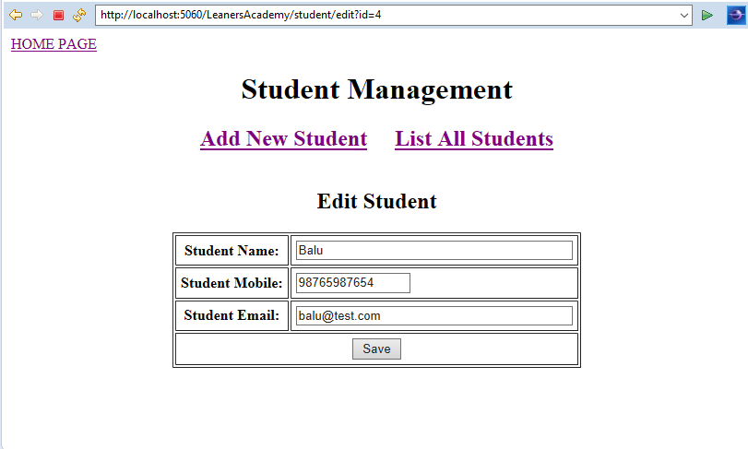

**Outputs-Screenshots:- After successful updation it redirects to students list**



**Outputs-Screenshots:- Click on delete button to delete the student details-once user deleted the student, it will refresh the data-deleted the record from the list.**

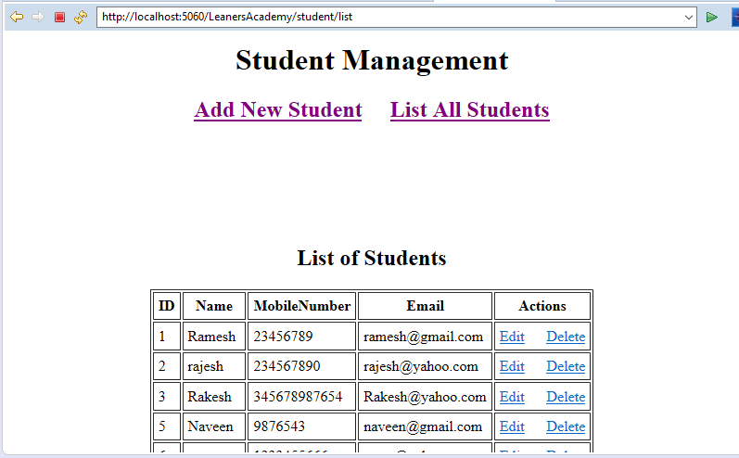

**Outputs-Screenshots:- Click on Home Button to go back to Menu Options:**



**Outputs-Screenshots:- Click on Subjects list to display Manage Subjects**

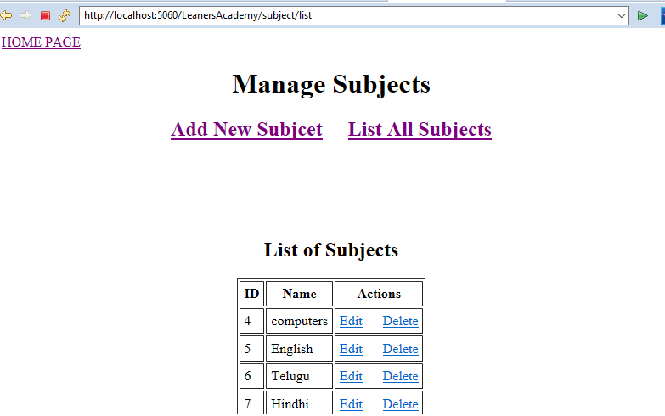

**Outputs-Screenshots:- Click on add new subject to add new the subject**

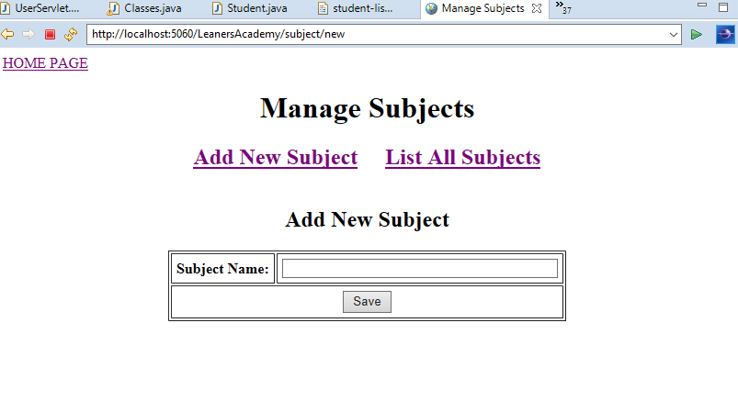

**Outputs-Screenshots:- Click on save subject to save the subject**

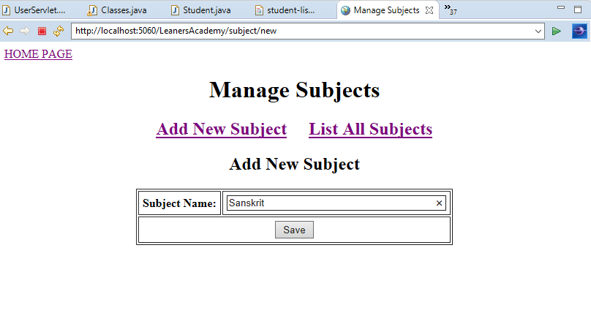

**Outputs-Screenshots:- After successful entry it will redirect to subjects list page**

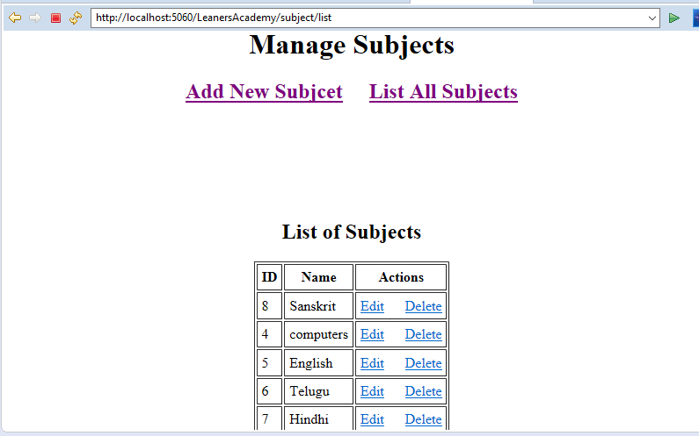

**Outputs-Screenshots:- To edit the subject details, click on edit option**

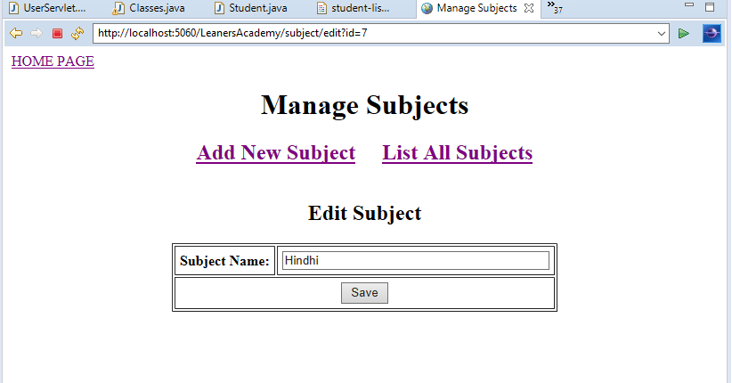

**Outputs-Screenshots:- After successful update it will redirect to subjects list page**



**Outputs-Screenshots:- To delete the subject, Sanskrit subject is deleted**

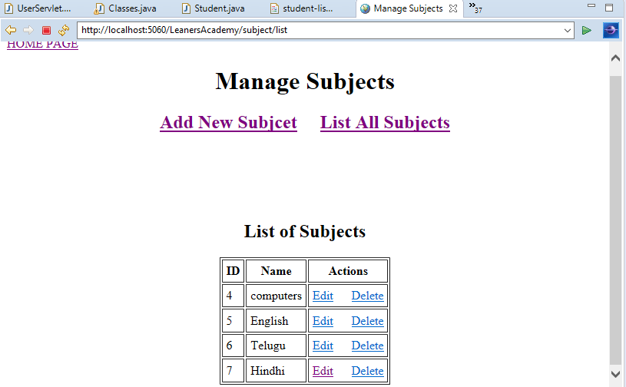

**Outputs-Screenshots:- Click on Home Button to go back to Menu Options**



**Outputs-Screenshots:- Select classes list from menu to display Class Management**

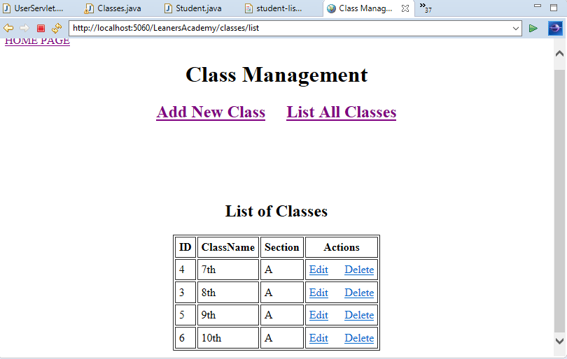

**Outputs-Screenshots:- Click on add new class to add the new class to the list**

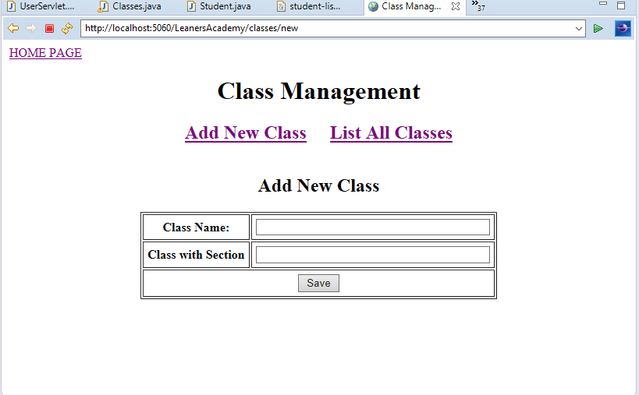

**Outputs-Screenshots:-Enter the details and click on save button to save the details.**

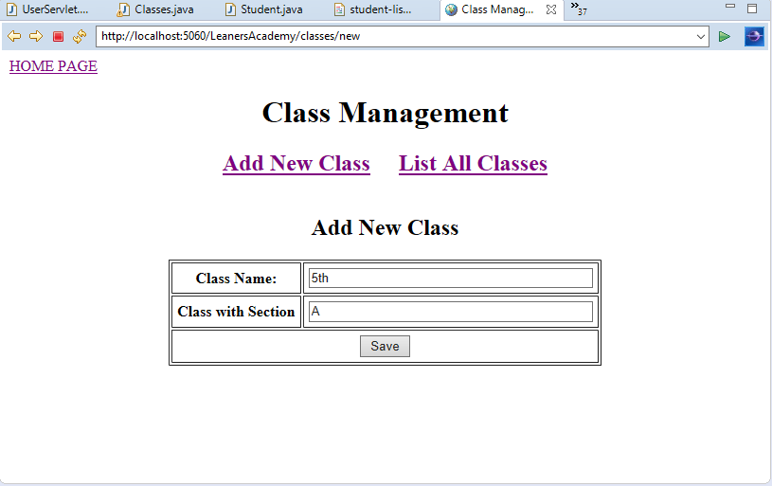

**Outputs-Screenshots:- After entering the data it will redirect to list of classes**

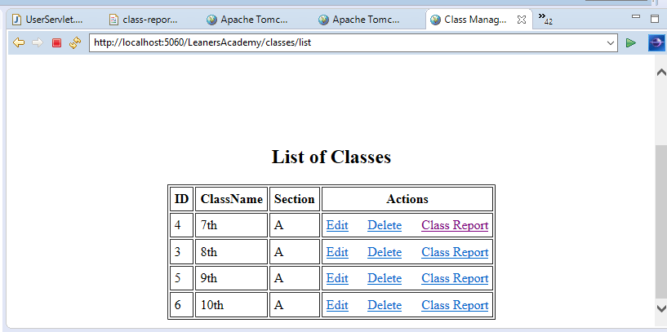

**Outputs-Screenshots:- Click on Class Report to view complete class Details**

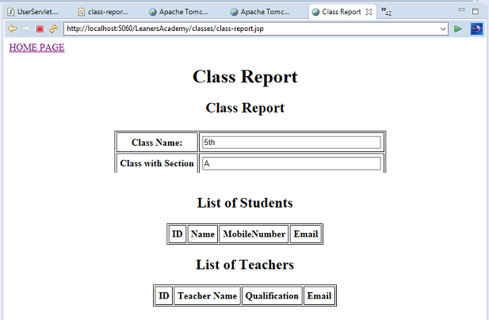

**Outputs-Screenshots:- Click on Home Button to go back to Menu Options**



**Outputs-Screenshots:- Select Assign Subject to Class to assign the subject to particular class**

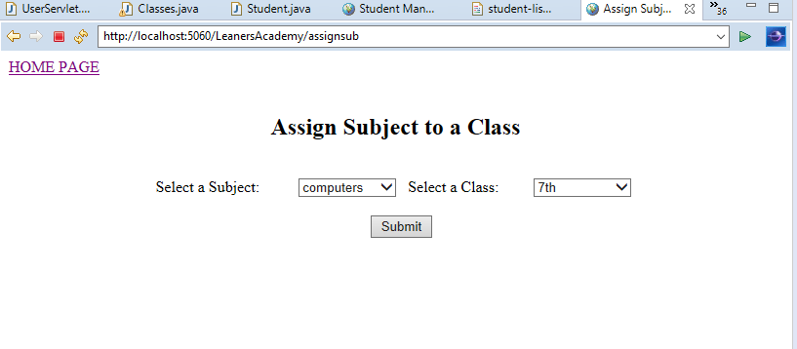

**Outputs-Screenshots:- Click on Home Button to go back to Menu Options:**



**Outputs-Screenshots:- Select Assign Teacher to a Subject and Class to assign a teacher to a class for the subject**

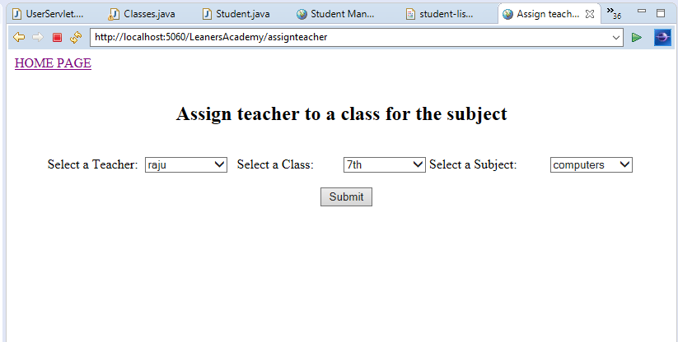

**Click on Home Button to go back to Menu Options:**



**Outputs-Screenshots:- Select Assign Student to a Class to assign a student to a class**

